

Antenna I

Final Project



July 1, 2017

Hossein Souri 810192398

Mohammad Mahmoodian 810192464

**Contents**

**Abstract** 6

**Question 1** 8

**Part a** 8

**Part b** 14

**Part c** 15

**Part d** 16

**i. For $l=\frac{λ}{4}$**  16

**ii. For $l=λ$**  18

**iii. For $l=2λ$**  22

**Part e** 25

**i. Phase shift of 15 degrees** 26

**ii. Phase shift of 30 degrees** 31

**iii. Phase shift of 60 degrees** 35

**Question 2** 40

**Part a** 40

**Part b** 44

**Part c** 48

**Question3** 49

**Part a** 49

**Part b and c** 50

**i. Beginning frequency (3GHz)** 50

**ii. Center frequency (4GHz)** 51

**iii. End frequency (5GHz)** 52

**Part d** 53

**Content of figures**

Figure 1. Center-fed linear dipole in HFSS 8

Figure 2. The radiation box of the dipole 8

Figure 3. The real part and imaginary part of input impedance 9

Figure 4. Directivity of the antenna in polar plot 9

Figure 5. Directivity in 3 dimensions 10

Figure 6. Directivity as a table 10

Figure 7. S11 of the antenna 11

Figure 8. Directivity of a standard dipole in polar plot 11

Figure 9. Directivity of a standard dipole antenna in 3 dimensions 12

Figure 10. Equations of directivity of a dipole antenna 12

Figure 11. Equations of input impedance of a dipole antenna 12

Figure 12. Summary of important parameters of a dipole antenna 13

Figure 13. Radiation pattern versus $θ$ 14

Figure 14. Radiation pattern of the antenna in 3 dimensions 14

Figure 15. current distribution on the dipole 15

Figure 16. Input impedance for $l=λ4$ 16

Figure 17. Directivity in polar plot for $l=λ4$ 16

Figure 18. Directivity in 3 dimensions for $l=λ4$ 17

Figure 19. S11 for $l=λ4$ 17

Figure 20. Current distribution on the dipole for $l=λ4$ 18

Figure 21. Input impedance for $l=λ$ 18

Figure 22. Directivity in polar plot for $l=λ$ 19

Figure 23. Directivity in 3 dimensions for $l=λ$ 19

Figure 24. S11 for $l=λ$ 20

Figure 25. Radiation pattern in polar plot for $l=λ$ 20

Figure 26. Radiation pattern in 3 dimensions for $l=λ$ 21

Figure 27. Radiation pattern in 3 dimensions in HFSS main view for $l=λ$ 21

Figure 28. Input impedance for $l=2λ$ 22

Figure 29. Directivity in polar plot for $l=2λ$ 22

Figure 30. Directivity in 3 dimensions for $l=2λ$ 23

Figure 31. S11 for $l=2λ$ 23

Figure 32. Radiation pattern in polar plot for $l=2λ$ 24

Figure 33. Radiation pattern in 3 dimensions in HFSS main view for $l=2λ$ 24

Figure 34. Array antenna of 4 dipole antennas 25

Figure 35. Array antenna in HFSS 25

Figure 36. Array antenna with radiation box 26

Figure 37. Input impedance for 15 degrees phase shift 26

Figure 38. Directivity versus $ϕ$ for 15 degrees phase shift 27

Figure 39. Directivity versus $θ$ for 15 degrees phase shift 27

Figure 40. Directivity in 3 dimensions for 15 degrees phase shift 28

Figure 41. S11 for 15 degrees phase shift 28

Figure 42. Total directivity in 2D view for 15 degrees phase shift 29

Figure 43. Total radiation pattern in 3D view for 15 degrees phase shift 29

Figure 44. Total radiation pattern in 3D in main HFSS view for 15 degrees phase shift 30

Figure 45. Current distribution along each dipole for 15 degrees phase shift 30

Figure 46. Input impedance for 30 degrees phase shift 31

Figure 47. Directivity versus $ϕ$ for 30 degrees phase shift 31

Figure 48. Directivity versus $θ$ for 30 degrees phase shift 32

Figure 49. Directivity in 3 dimensions for 30 degrees phase shift 32

Figure 50. S11 for 30 degrees phase shift 33

Figure 51. Total directivity in 2D view for 30 degrees phase shift 33

Figure 52. Radiation pattern versus θ for 30 degrees phase shift 34

Figure 53. Current distribution along each dipole for 30 degrees phase shift 34

Figure 54. Input impedance for 60 degrees phase shift 35

Figure 55. Directivity versus ϕ for 60 degrees phase shift 35

Figure 56. Directivity versus θ for 60 degrees phase shift 36

Figure 57. Directivity in 3 dimensions for 60 degrees phase shift 36

Figure 58. S11 for 60 degrees phase shift 37

Figure 59. Total radiation pattern in 2D view for 60 degrees phase shift 37

Figure 60. Radiation pattern versus θ for 60 degrees phase shift 38

Figure 61. Total radiation pattern in 3D in main HFSS view for 60 degrees phase shift 38

Figure 62. Current distribution along each dipole for 60 degrees phase shift 39

Figure 63. Current distribution along each dipole for 90 degrees phase shift 39

Figure 64. The aperture antenna in HFSS 40

Figure 65. E plane 1 40

Figure 66. E plane 2 41

Figure 67. E plane 3 41

Figure 68. H plane 1 41

Figure 69. H plane 2 42

Figure 70. H plane 3 42

Figure 71. Radiation pattern versus ϕ 42

Figure 72. Radiation pattern versus $θ$ 43

Figure 73. Radiation pattern in 3D view 43

Figure 74. Directivity versus $ϕ$ 43

Figure 75. E plane 1 with decreased ground 44

Figure 76. E plane 2 with decreased ground 44

Figure 77. E plane 3 with decreased ground 45

Figure 78. H plane 1 with decreased ground 45

Figure 79. H plane 2 with decreased ground 45

Figure 80. H plane 3 with decreased ground 46

Figure 81. Radiation pattern in 3D view with decreased ground 46

Figure 82. Radiation pattern versus $θ$ with decreased ground 46

Figure 83. Radiation pattern versus ϕ with decreased ground 47

Figure 84. Directivity versus $ϕ$ with decreased ground 47

Figure 85. S11 for the ground size of $10λ*10λ$ 48

Figure 86. S11 for the ground size of $5λ*5λ$ 48

Figure 87. Spiral antenna 49

Figure 88. S11 49

Figure 89. Radiation pattern versus $θ$ for 3GHz 50

Figure 90. Directivity for 3GHz 50

Figure 91. Gain for 3GHz 51

Figure 92. Radiation pattern versus $θ$ for 4GHz 51

Figure 93. Directivity for 4GHz 51

Figure 94. Gain for 4GHz 52

Figure 95. Radiation versus $θ$ for 5GHz 52

Figure 96. Directivity for 5GHz 52

Figure 97. Gain for 5GHz 53

Figure 98. Magnitude of current 53

Figure 99. Current vector 54

# **Abstract**

This project is mainly about simulation an antenna in HFSS and comparing the results obtained from simulation and the theory results.

This project consist of three part:

Question 1:

* Designing and simulation if a 0.47 $λ$, 0.25 $λ$, 1 $λ$ and 2 $λ$
* Calculating the directivity and input impedance.
* S parameters of antenna
* Radiation pattern
* Operation bandwidth
* Current distribution

In part 2 all the above had done for an array dipole antenna.

Question 2:

In question 2 a rectangular aperture antenna with different diameters has been simulated in HFSS and the following have been obtained:

* E-plane and H-plane
* S11
* Directivity
* Radiation pattern
* Current distribution

Question 3:

In question 3 symmetrical two-wire planar spiral has been designed it operate at the frequencies: $f≥3 GHz$. And the followings have been resulted:

* S11 versus frequency
* Operation bandwidth
* Radiation pattern
* Gain and directivity
* Current distribution

# **Question 1**

A center-fed linear dipole of l= 0.47λ and a = 0.005λ, operating at the frequency of 3 GHz is simulated in HFSS.

## **Part a**

In this part firstly we would calculate the input impedance and directivity. Then we would compare to what we expect for a half-wave dipole.

The dipole is implemented in HFSS.

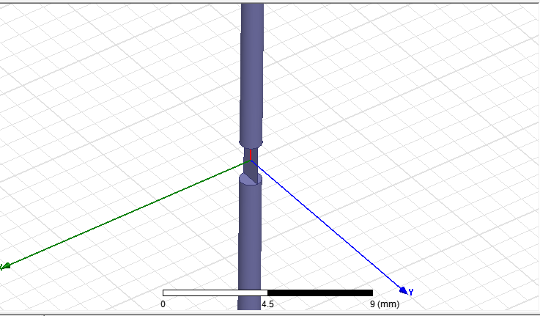

Figure . Center-fed linear dipole in HFSS

Its radiation box is as follows:

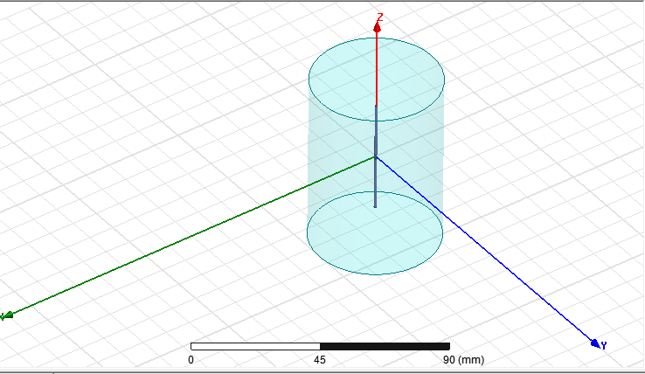

Figure . The radiation box of the dipole

The real part and imaginary part of input impedance of dipole antenna is plotted here:

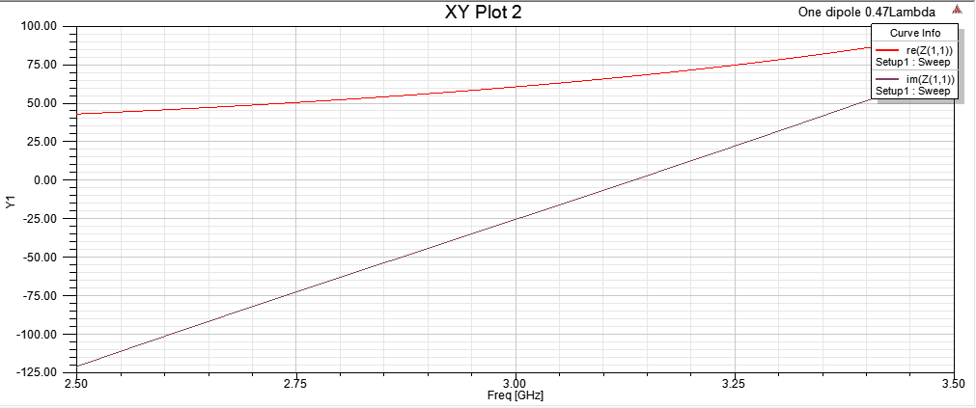

Figure . The real part and imaginary part of input impedance

The directivity is plotted in two dimensions here:

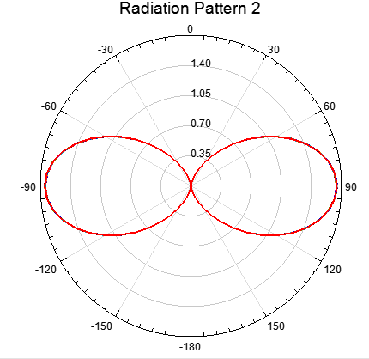

Figure . Directivity of the antenna in polar plot

The directivity is plotted in three dimensions here:

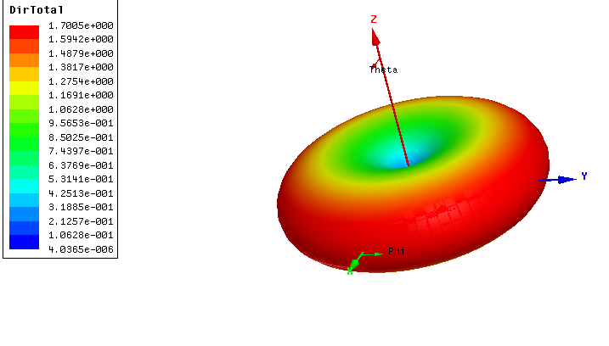

Figure . Directivity in 3 dimensions

We would also report the directivity in a table for better understanding of its peak.

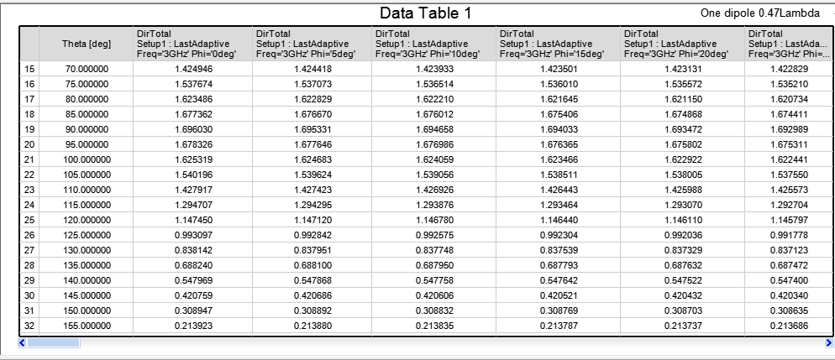

Figure . Directivity as a table

In addition, S11 of this antenna is reported here:

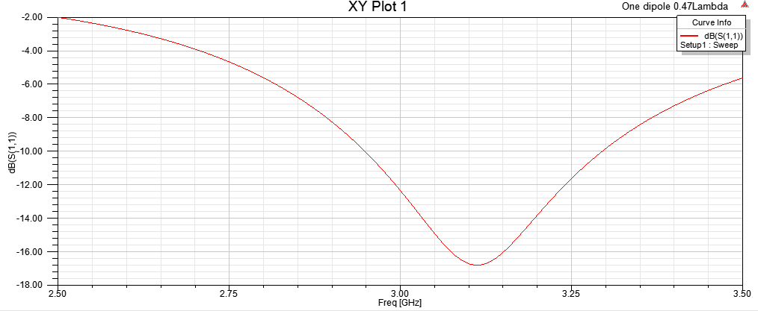

Figure . S11 of the antenna

According to the definition of bandwidth we should consider the frequencies in which S11 in lower than -10dB. Having this in mind we can say that the bandwidth of antenna is from 2.95 GHz to 3.3GHz which is around 350 MHz. Now we are going to verify our simulations with theory of antenna which is discussed in the class.

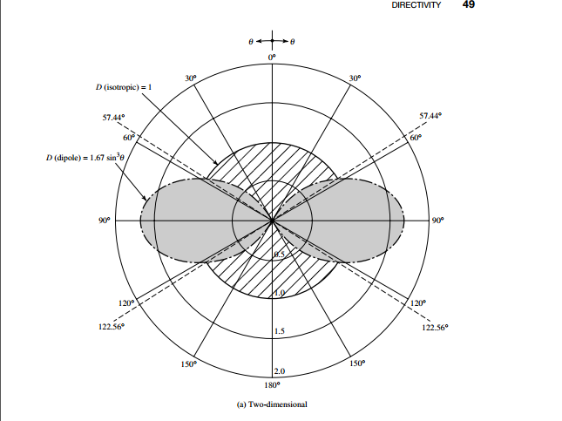

Figure . Directivity of a standard dipole in polar plot

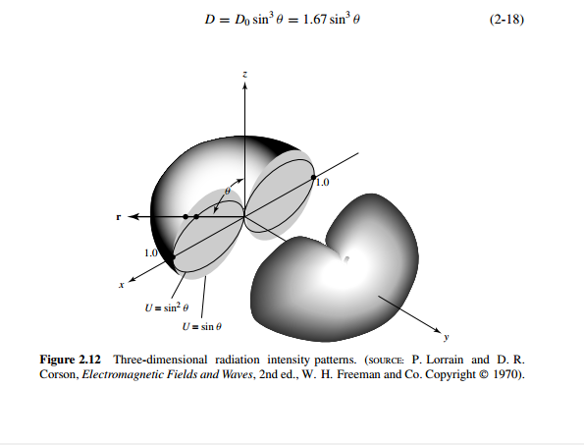

Figure . Directivity of a standard dipole antenna in 3 dimensions

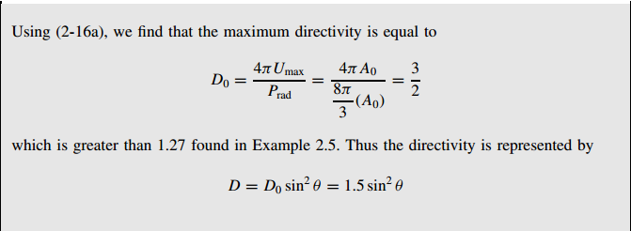

Figure . Equations of directivity of a dipole antenna

So the directivity is the same as theory. And here is the input impedance from the reference book of the course:

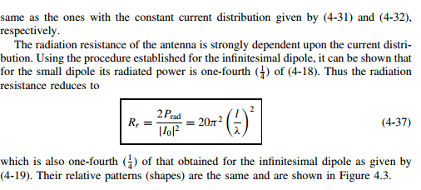

Figure . Equations of input impedance of a dipole antenna

And this table is summary of important parameters of a dipole antenna in Antenna Theory of Balanis:

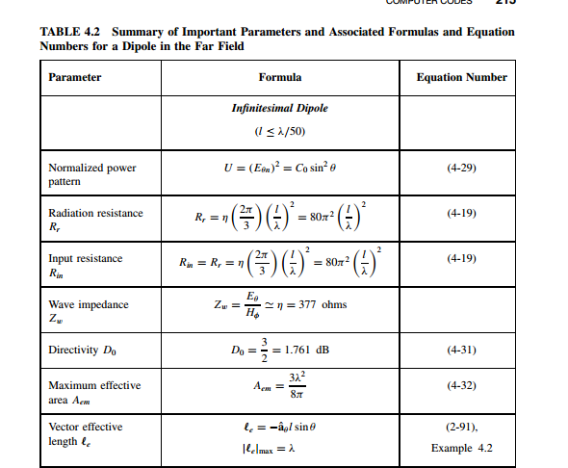

Figure . Summary of important parameters of a dipole antenna

## **Part b**

HFSS has derived the radiation pattern. It is presented here:

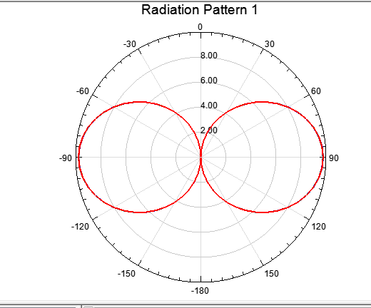

Figure . Radiation pattern versus $θ$

The radiation pattern is plotted in three dimensions, here.

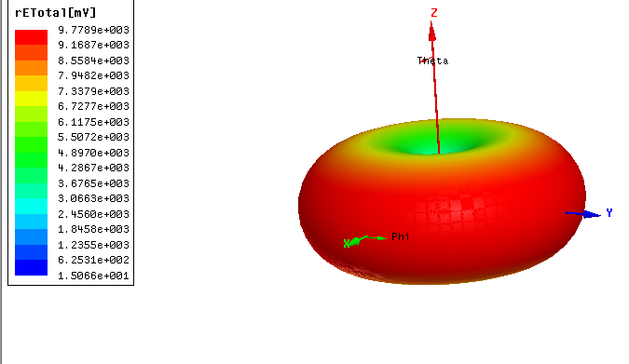

Figure . Radiation pattern of the antenna in 3 dimensions

## **Part c**

The current distribution on the dipole is drawn here:

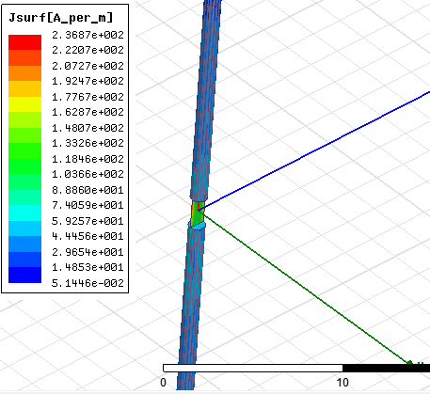

Figure . current distribution on the dipole

And as we can see the current is similar to a sinusoidal wave.

## **Part d**

### **i. For $l=\frac{λ}{4}$**

This procedure will be repeated for $l=\frac{λ}{4}$.The input impedance of antenna is illustrated versus frequency as the following graph:

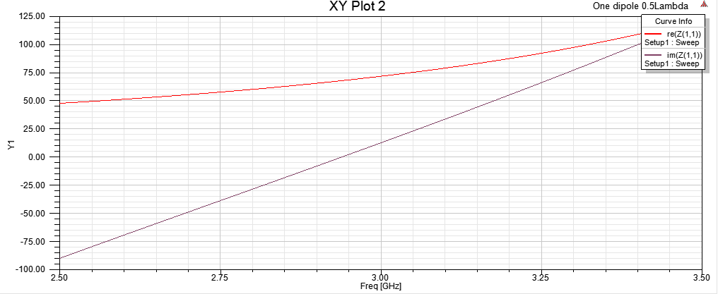

Figure . Input impedance for

The directivity is plotted in two dimensions and three dimensions here:

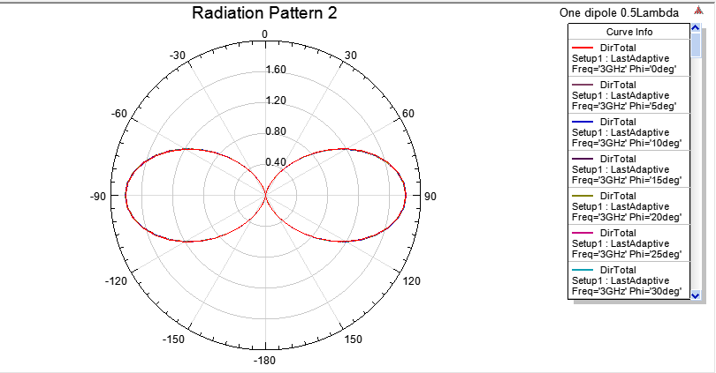

Figure . Directivity in polar plot for

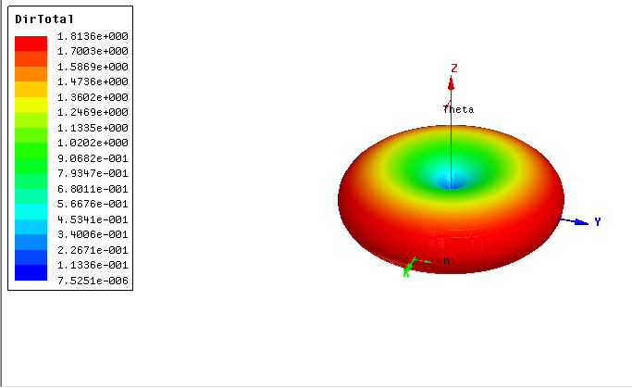

Figure . Directivity in 3 dimensions for

The below pictures depicts the plot of S11.

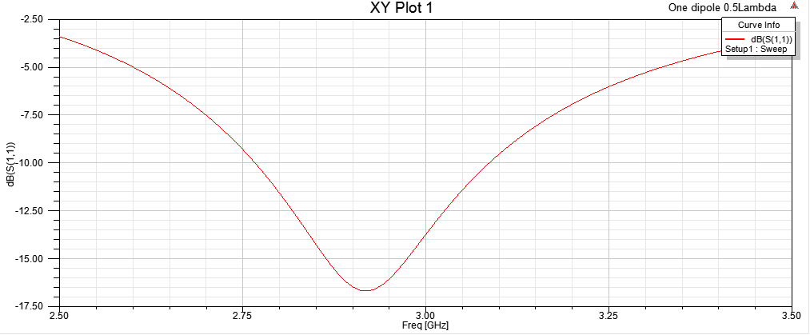

Figure . S11 for $l=\frac{λ}{4}$

According to the definition of bandwidth we should consider the frequencies in which S11 in lower than -10dB. Having this in mind we can say that the band width of antenna is from 2.77 GHz to 3.08GHz which is around 310 MHz.

The current distribution on the dipole is drawn here:

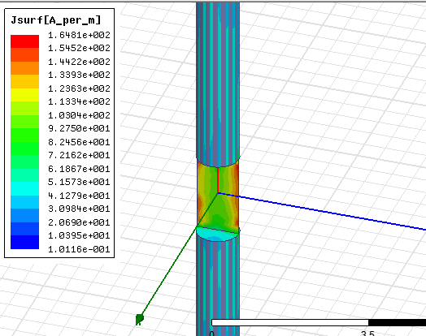

Figure . Current distribution on the dipole for $l=\frac{λ}{4}$

### **ii. For $l=λ$**

This procedure will be repeated for $l=λ$. The input impedance of antenna is illustrated versus frequency as the following graph:

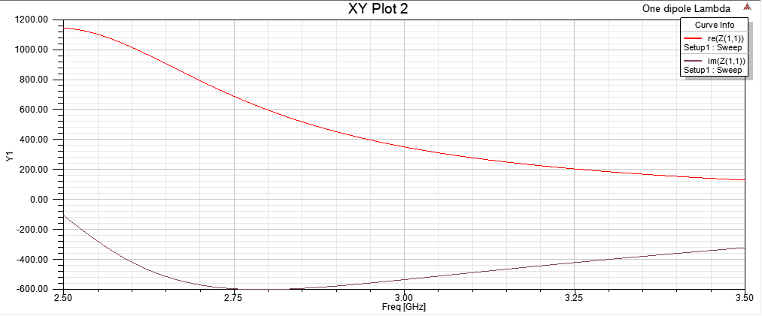

Figure . Input impedance for

­­­

The directivity is plotted in two dimensions and three dimensions here:

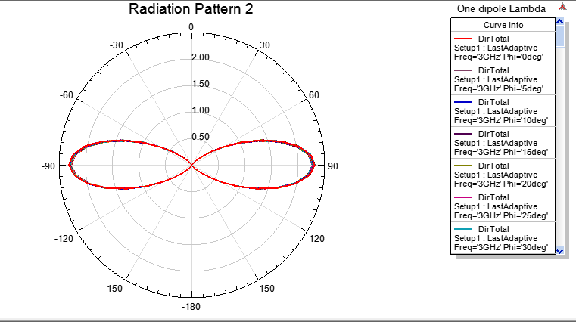

Figure . Directivity in polar plot for

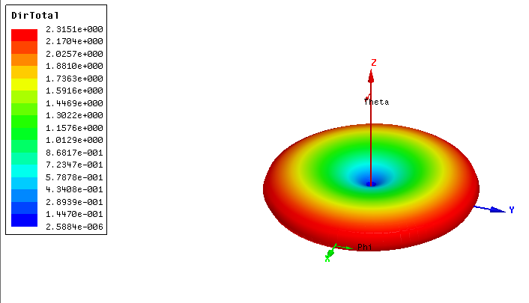

Figure . Directivity in 3 dimensions for

The below pictures depicts the plot of S11.

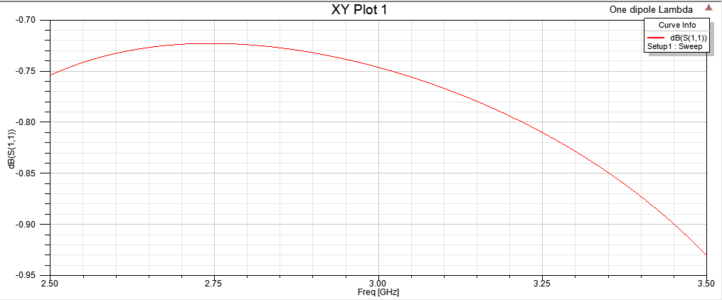

Figure . S11 for $l=λ$

The bandwidth is not as good as previous antennas. It is not below -10dB around 3GHz. Finally, the following graph represents radiation pattern of antenna:

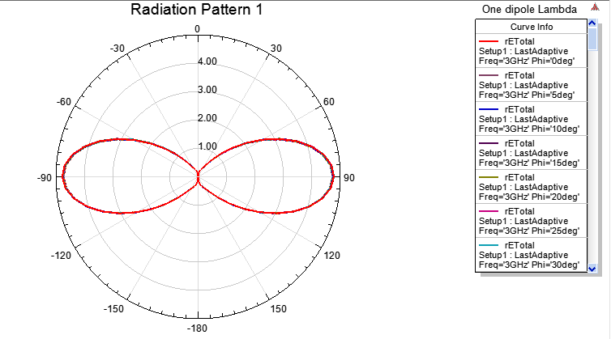

Figure . Radiation pattern in polar plot for

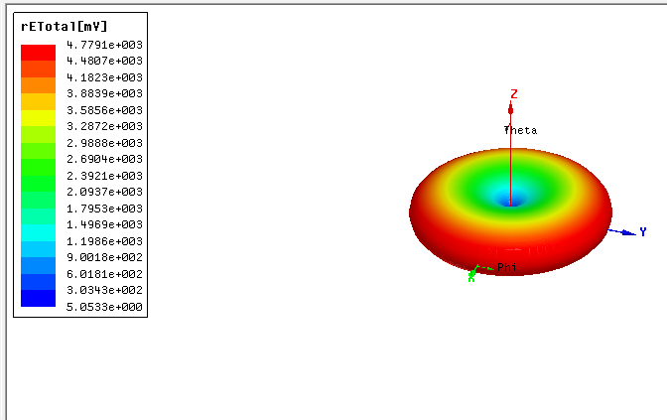

Figure . Radiation pattern in 3 dimensions for $l=λ$

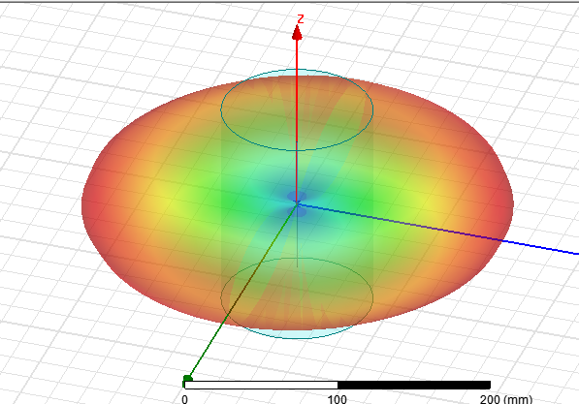

Figure . Radiation pattern in 3 dimensions in HFSS main view for $l=λ$

### **iii. For $l=2λ$**

This procedure will be repeated for $l=2λ$. The input impedance of our antenna in this length is presented here:

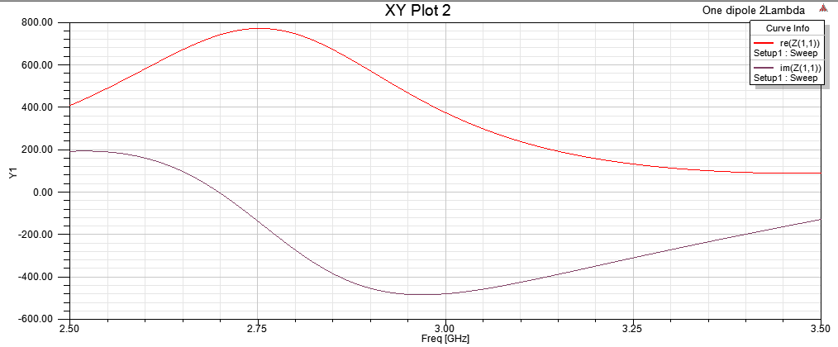

Figure . Input impedance for $l=2λ$

The directivity of antenna changes like the below picture:

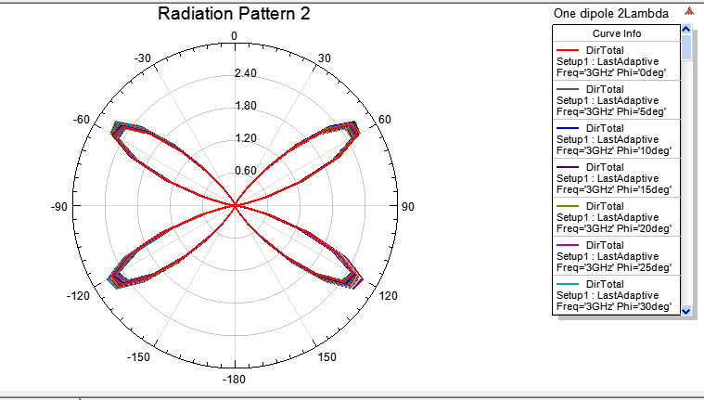

Figure . Directivity in polar plot for

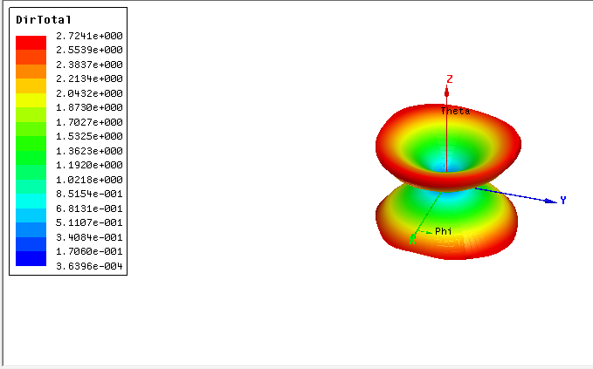

Figure . Directivity in 3 dimensions for $l=2λ$

S11 of our antenna is just as the blow the picture. It is a very significant feature of antenna.

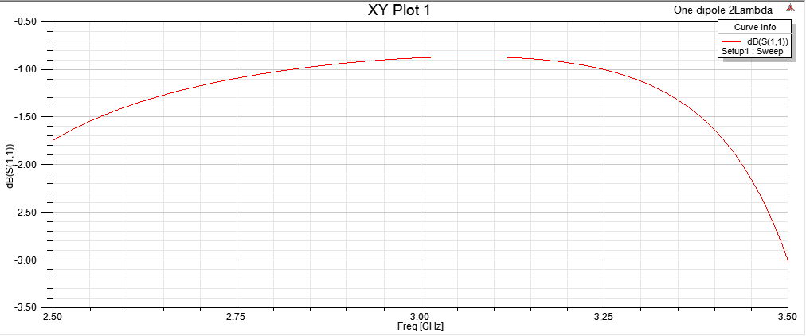

Figure . S11 for $l=2λ$

The bandwidth is not as good as previous antennas. It is not below -10dB around 3GHz. The radiation pattern changes like the below picture:

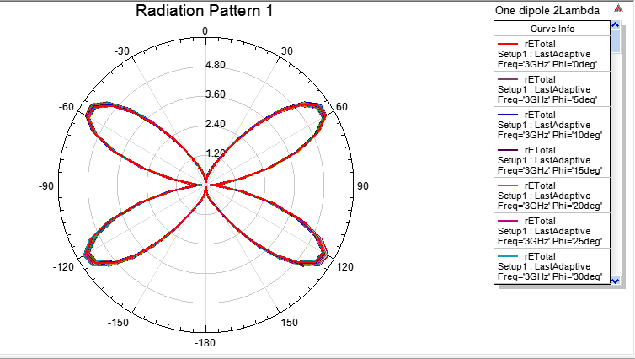

Figure . Radiation pattern in polar plot for

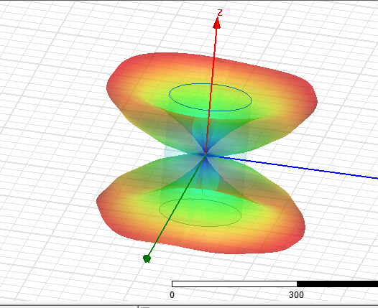

Figure . Radiation pattern in 3 dimensions in HFSS main view for $l=2λ$

## **Part e**

In this part we should consider a 4-element linear array of the mentioned dipole (l= 0.47λ) as shown below.

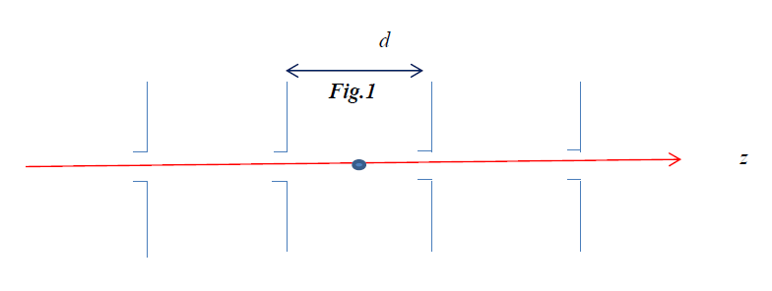

Figure . Array antenna of 4 dipole antennas

Where d= λ/8 . We should simulate the whole array, and plot the pattern for different phase shifts.

This structure is implemented in HFSS like the below picture.

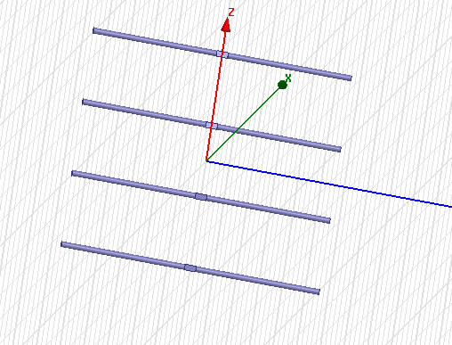

Figure . Array antenna in HFSS

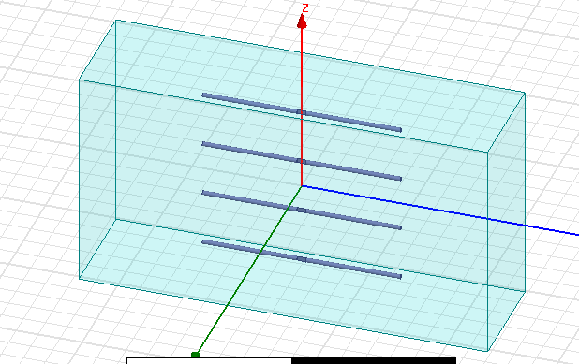

Figure . Array antenna with radiation box

### **i. Phase shift of 15 degrees**

The input impedance of antenna is illustrated here:

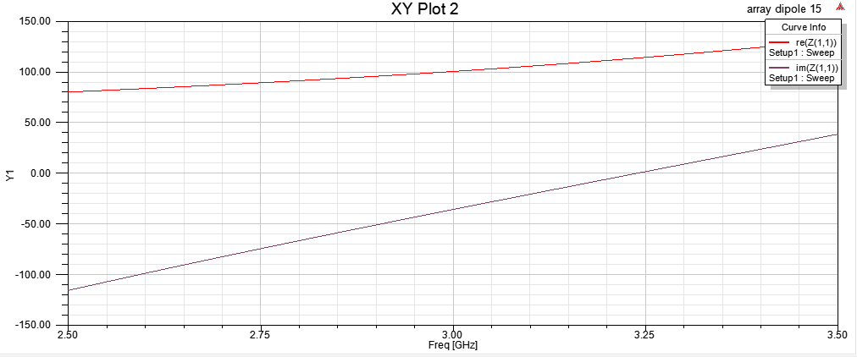

Figure . Input impedance for 15 degrees phase shift

The directivity versus phi is depicted in the following graph.

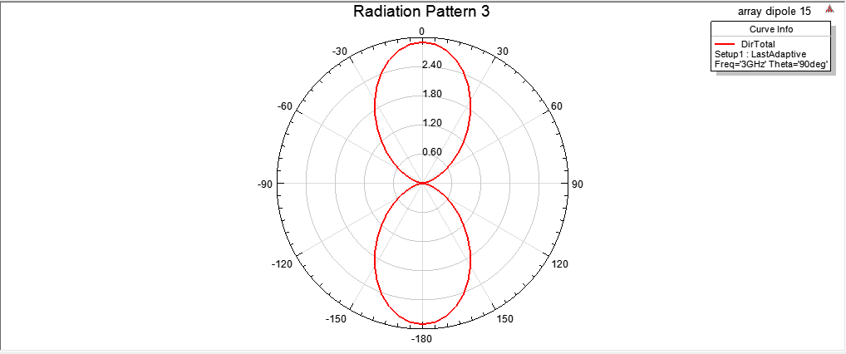

Figure . Directivity versus $ϕ$ for 15 degrees phase shift

The directivity versus theta is depicted in the following graph.

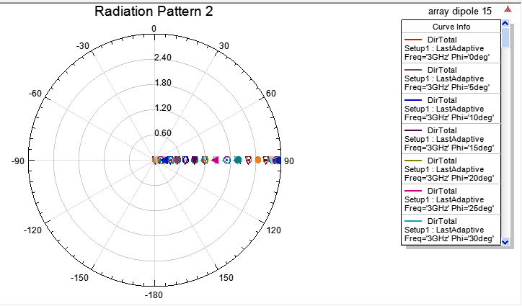

Figure . Directivity versus $θ$ for 15 degrees phase shift

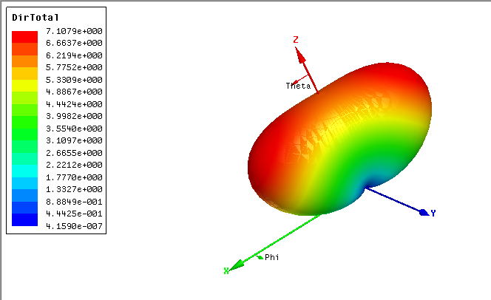

Figure . Directivity in 3 dimensions for 15 degrees phase shift

We have also depicted S11. Here it is:

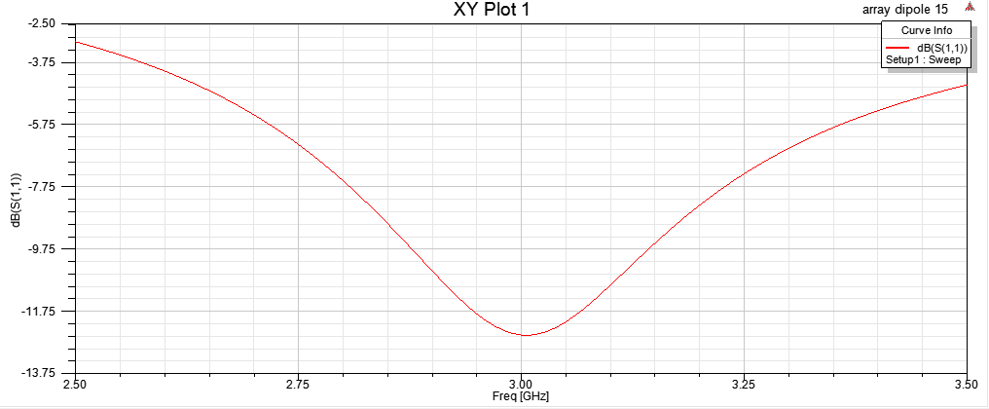

Figure . S11 for 15 degrees phase shift

According to the definition of bandwidth we should consider the frequencies in which S11 in lower than -10dB. Having this in mind we can say that the band width of antenna is from 2.8 GHz to 3.125 GHz which is around 325 MHz. The pattern of antenna is presented by a 3-D and 2-D plot:

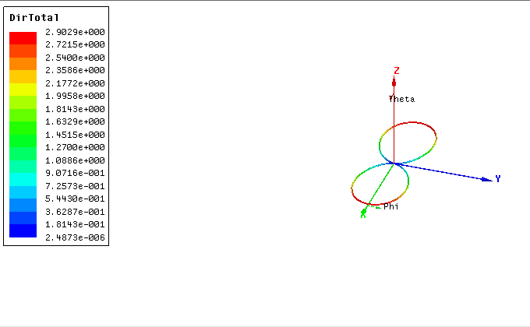

Figure 42. Total directivity in 2D view for 15 degrees phase shift

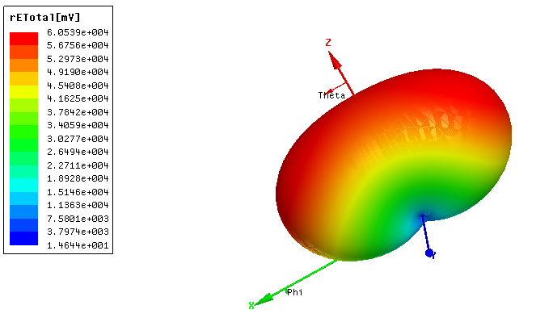

Figure . Total radiation pattern in 3D view for 15 degrees phase shift

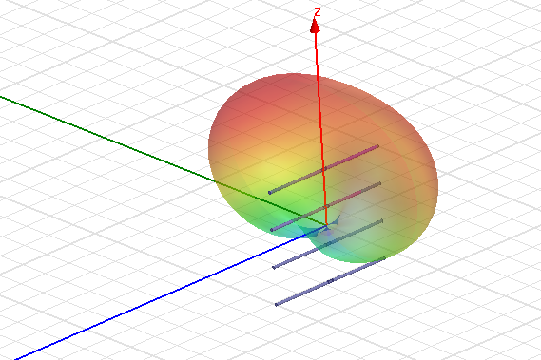

Figure . Total radiation pattern in 3D in main HFSS view for 15 degrees phase shift

We should also report the current distribution along each dipole in pattern.

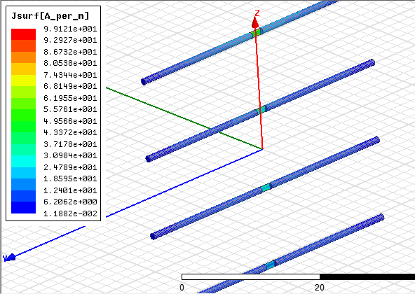

Figure . Current distribution along each dipole for 15 degrees phase shift

### **ii. Phase shift of 30 degrees**

The input impedance of antenna is illustrated here:

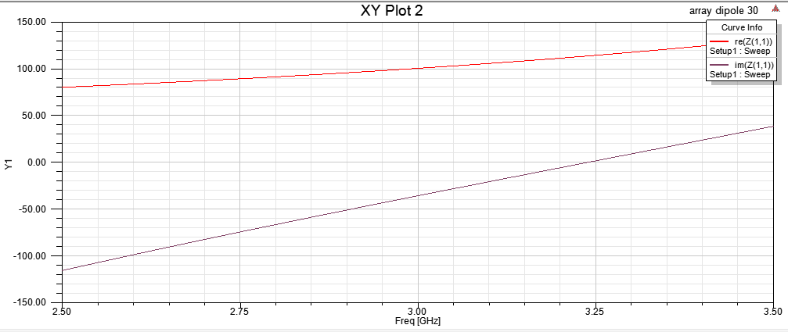

Figure . Input impedance for 30 degrees phase shift

The directivity of antenna versus phi is illustrated here.

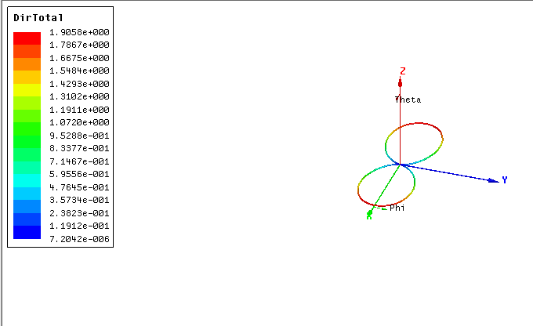

Figure . Directivity versus $ϕ$ for 30 degrees phase shift

The directivity of antenna versus theta is illustrated here.

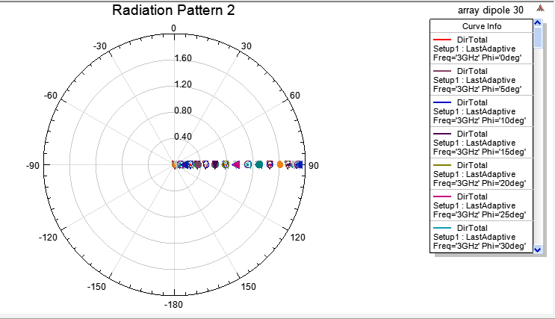

Figure . Directivity versus $θ$ for 30 degrees phase shift

And here is the 3-D directivity.

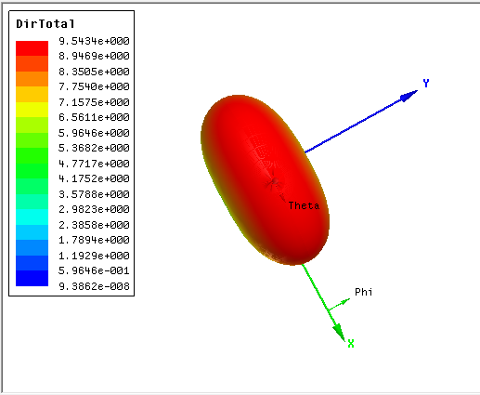

Figure . Directivity in 3 dimensions for 30 degrees phase shift

The graph of S11 is just like the following picture.

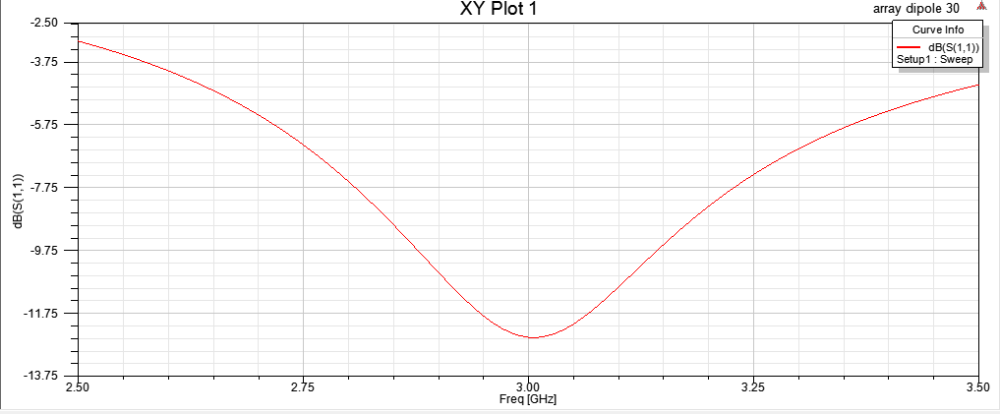

Figure . S11 for 30 degrees phase shift

According to the definition of bandwidth we should consider the frequencies in which S11 in lower than -10dB. Having this in mind we can say that the band width of antenna is from 2.8 GHz to 3.125 GHz which is around 325 MHz. The pattern of antenna is presented by a 3-D and 2-D plot:

The radiation pattern versus phi is illustrated here.

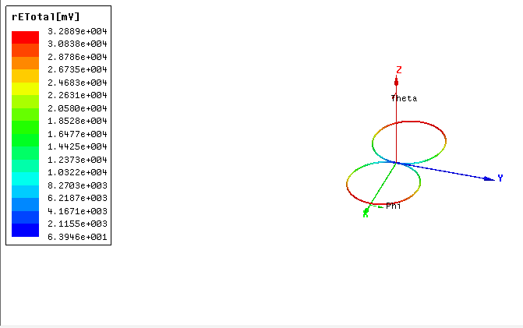

Figure . Total directivity in 2D view for 30 degrees phase shift

The radiation pattern versus theta is illustrated here.

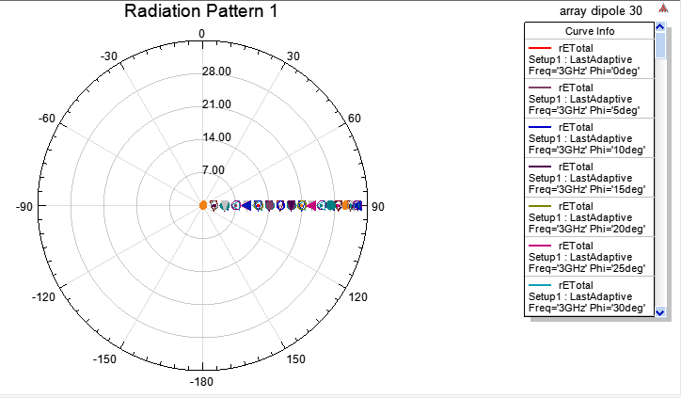

Figure . Radiation pattern versus θ for 30 degrees phase shift

The distribution of current along the dipoles are just like the below picture.



Figure . Current distribution along each dipole for 30 degrees phase shift

### **iii. Phase shift of 60 degrees**

The input impedance of antenna is illustrated here:

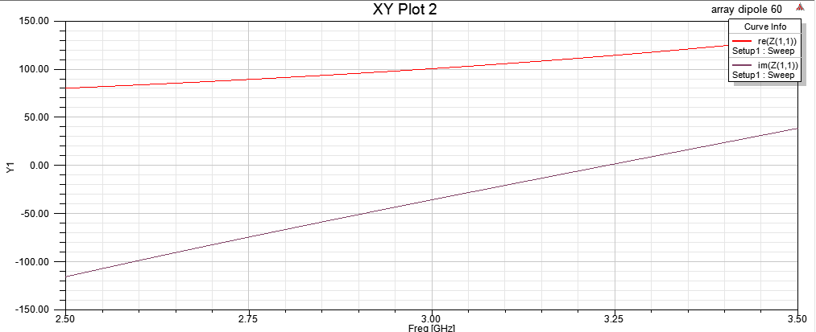

Figure . Input impedance for 60 degrees phase shift

The directivity of antenna versus $ϕ$ is illustrated here.

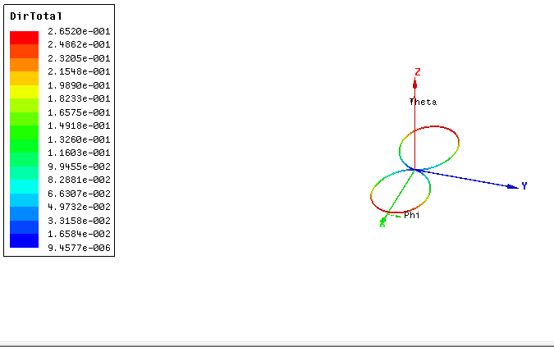

Figure . Directivity versus ϕ for 60 degrees phase shift

The directivity of antenna versus theta is illustrated here.

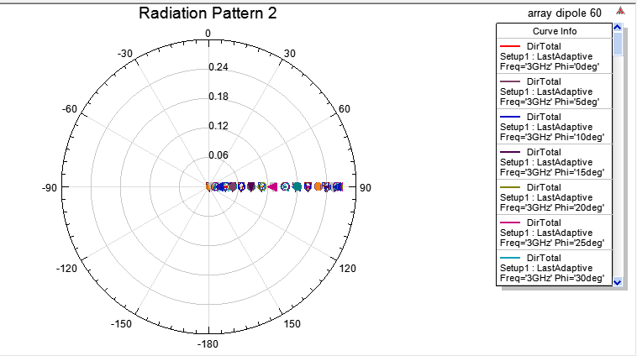

Figure . Directivity versus θ for 60 degrees phase shift

We have also reported 3-D directivity:

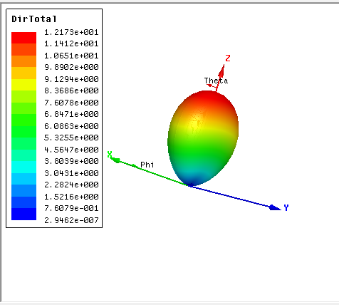

Figure . Directivity in 3 dimensions for 60 degrees phase shift

The graph of S11 is just like the following picture.

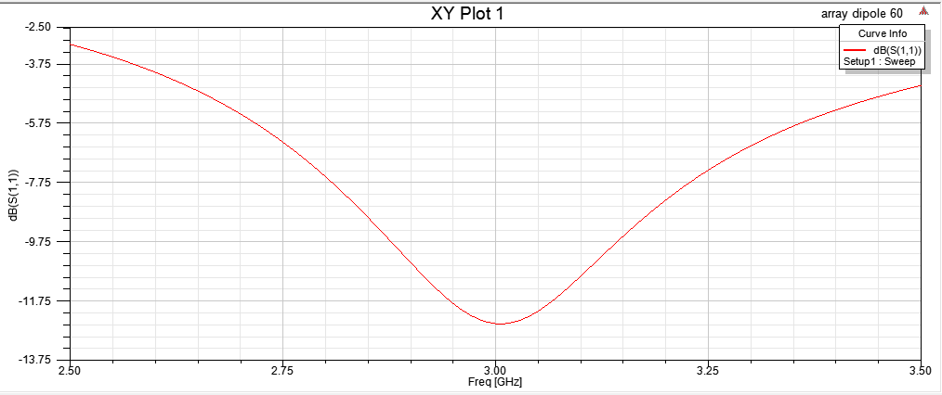

Figure . S11 for 60 degrees phase shift

According to the definition of bandwidth we should consider the frequencies in which S11 in lower than -10dB. Having this in mind we can say that the band width of antenna is from 2.81 GHz to 3.125 GHz which is around 324 MHz. The pattern of antenna is presented by a 3-D and 2-D plot:

The radiation pattern versus $ϕ$ is illustrated here.

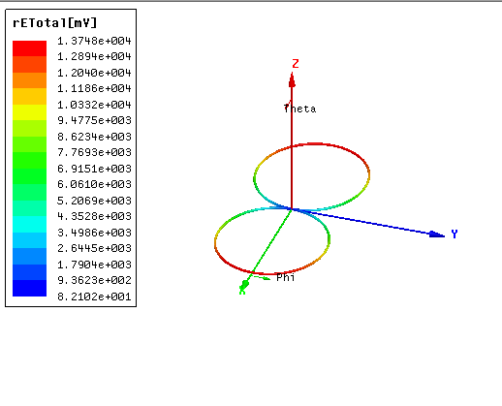

Figure . Total radiation pattern in 2D view for 60 degrees phase shift

The radiation pattern versus theta is illustrated here.

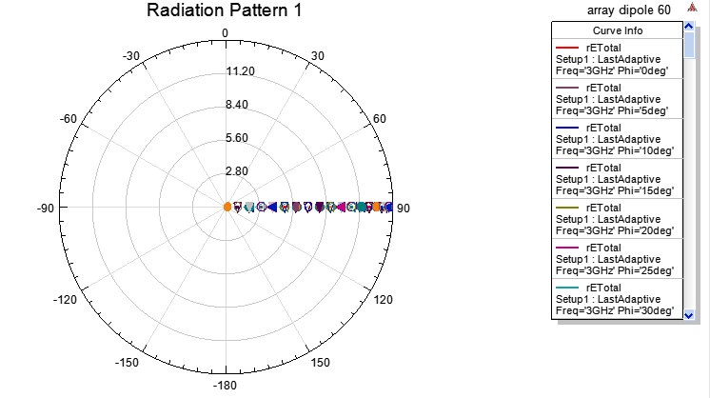

Figure . Radiation pattern versus θ for 60 degrees phase shift

We have also reported 3-D radiation pattern:

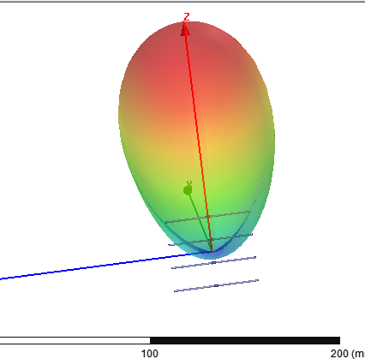

Figure . Total radiation pattern in 3D in main HFSS view for 60 degrees phase shift

Finally, we should report the current distribution on the dipoles

The distribution of current along the dipoles are just like the below picture.

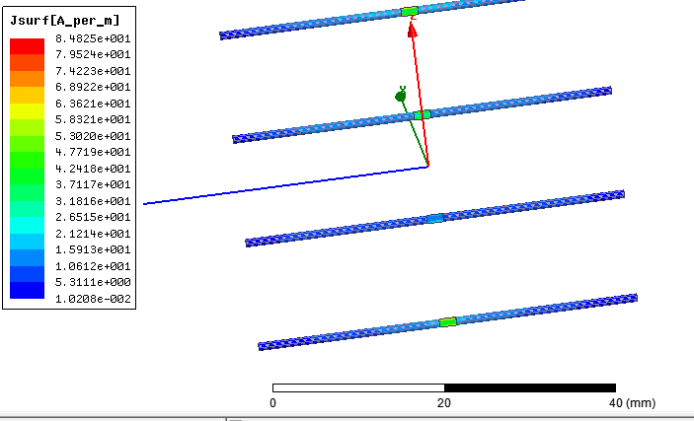

Figure . Current distribution along each dipole for 60 degrees phase shift

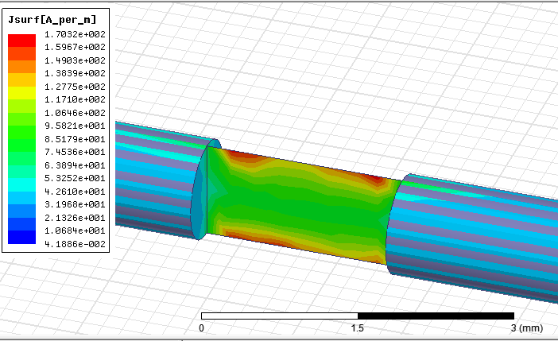

Figure . Current distribution along each dipole for 90 degrees phase shift

# **Question 2**

A waveguide fed with rectangular aperture antenna with dimensions of a=3 λ and b=2 λ, in the x and y directions, respectively. Operation frequency is 3 GHz and the ground size is 10 λ x 10 λ. We should consider that the waveguide is excited in its dominant mode of TE10. This structure is implemented in HFSS as follows:

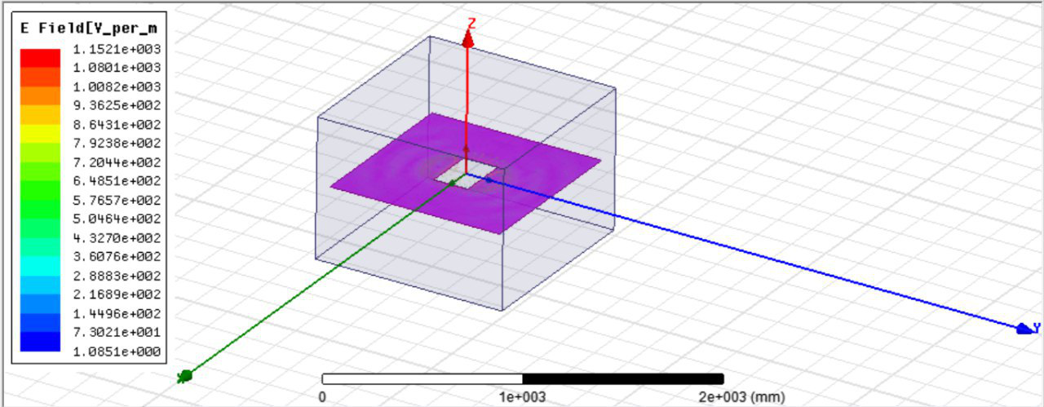

Figure . The aperture antenna in HFSS

## **Part a**

E plane is like the following figure:

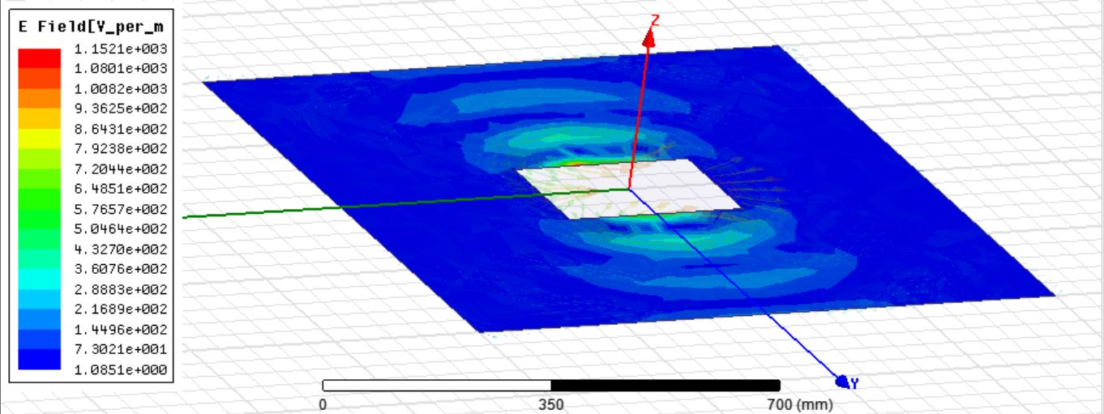

Figure . E plane 1

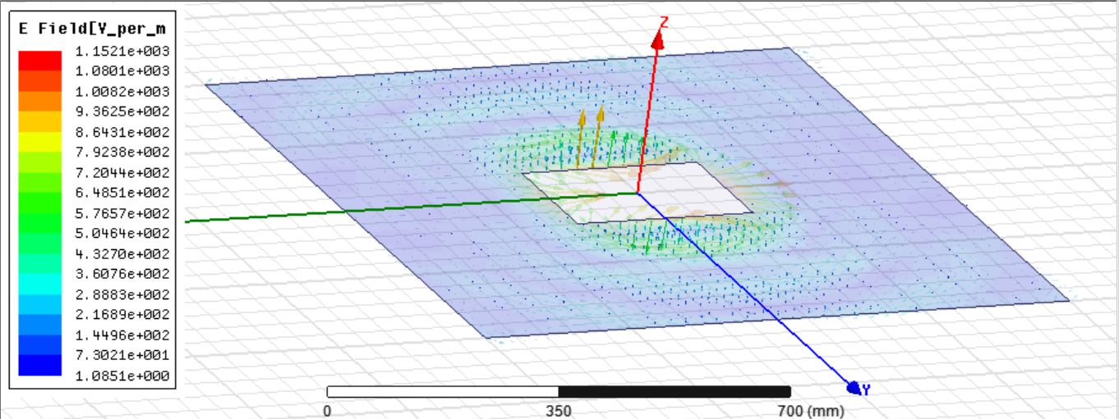

Figure . E plane 2

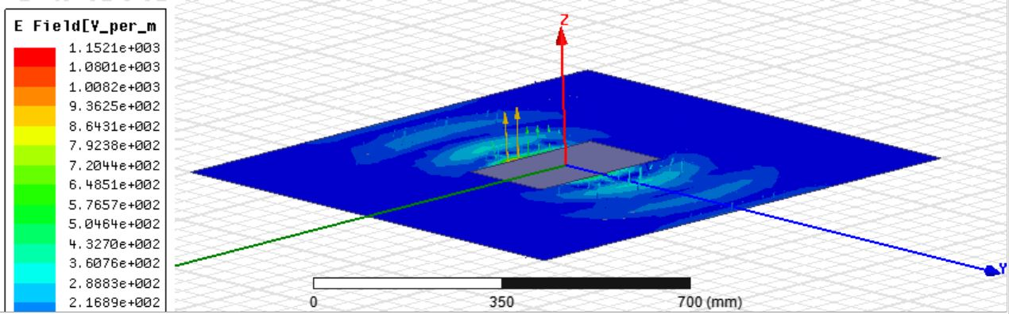

Figure . E plane 3

H plane is like the following figure:

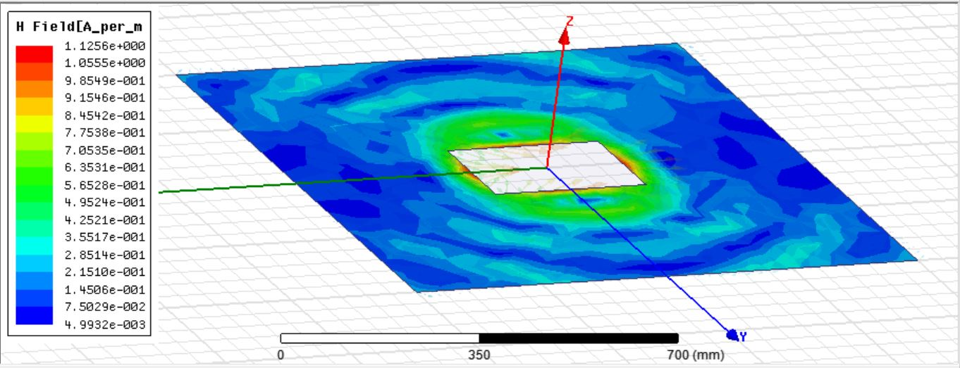

Figure . H plane 1

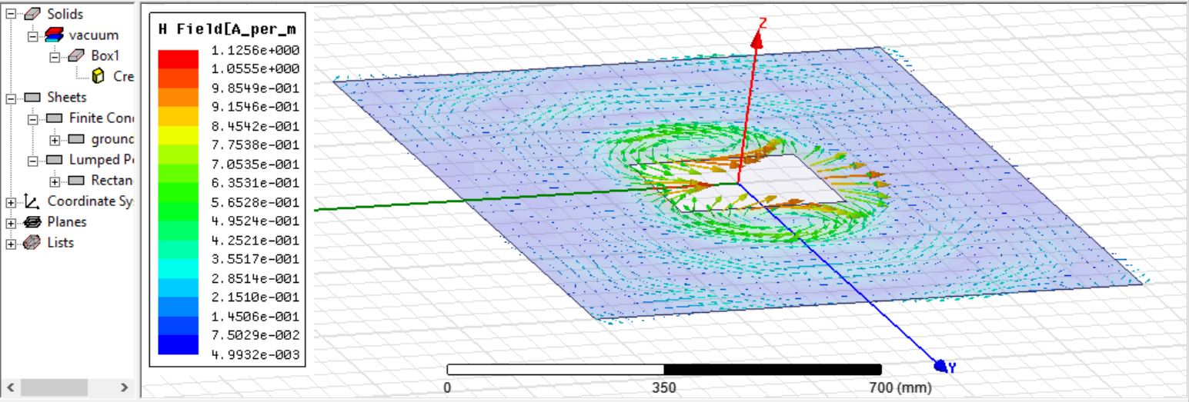

Figure . H plane 2

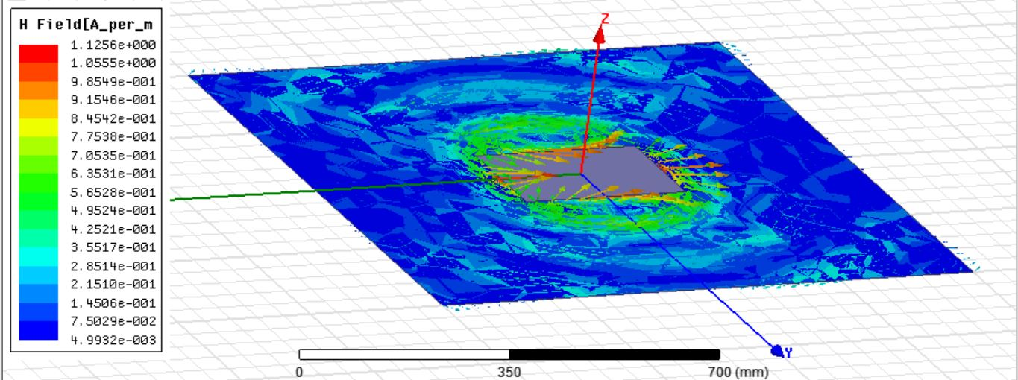

Figure . H plane 3

For further analysis, we will analyze radiation pattern and directivity of the antenna.

Radiation pattern versus $ϕ$:

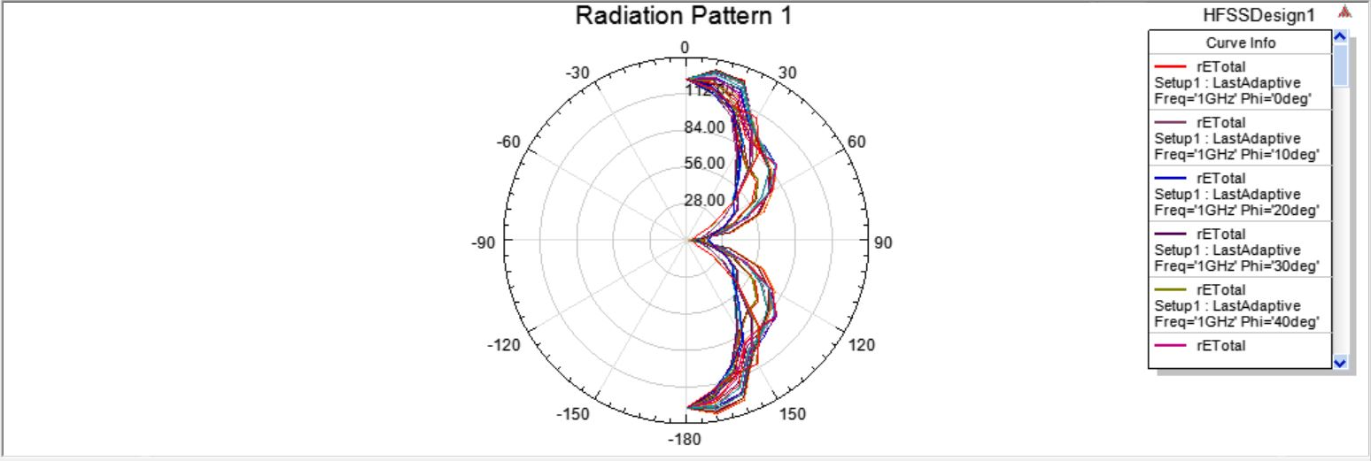

Figure . Radiation pattern versus ϕ

Radiation pattern versus $θ$:

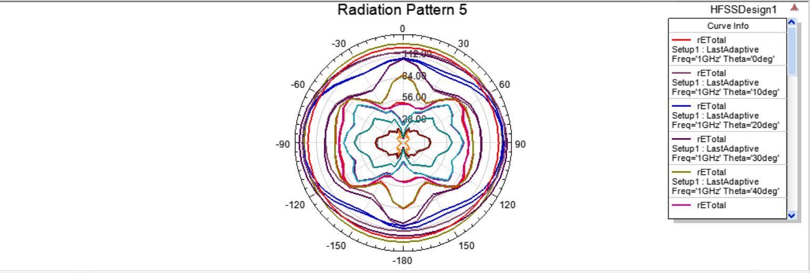

Figure . Radiation pattern versus $θ$

3-D radiation pattern:

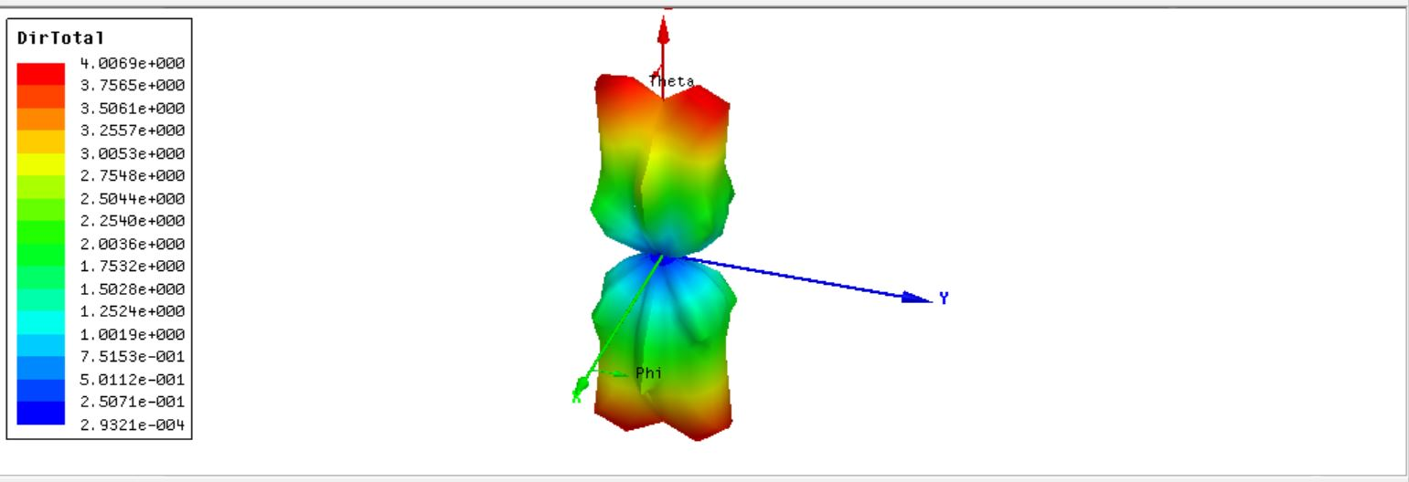

Figure . Radiation pattern in 3D view

Directivity versus $ϕ$:

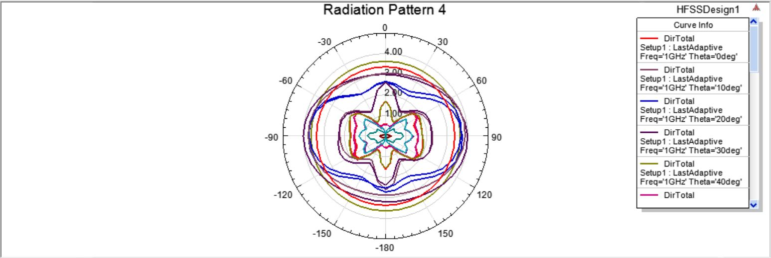

Figure . Directivity versus $ϕ$

## **Part b**

In this part we should decrease the size of the ground to 5 λ × 5 λ, and repeat part a. E plane is like the following figure:

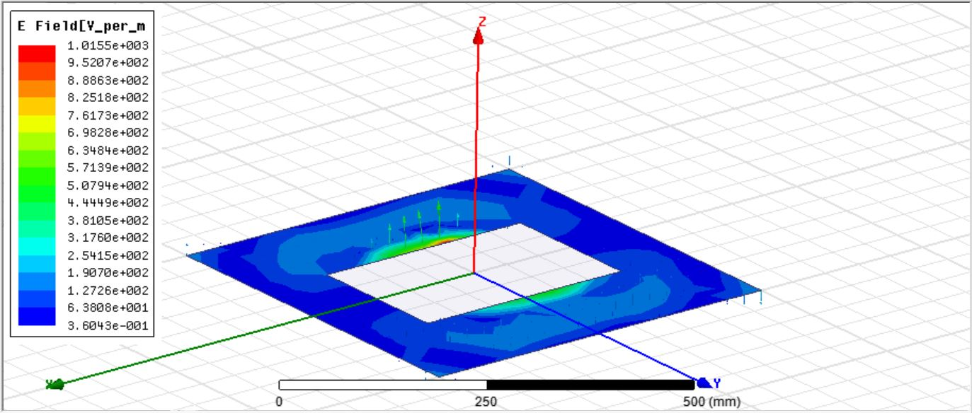

Figure . E plane 1 with decreased ground

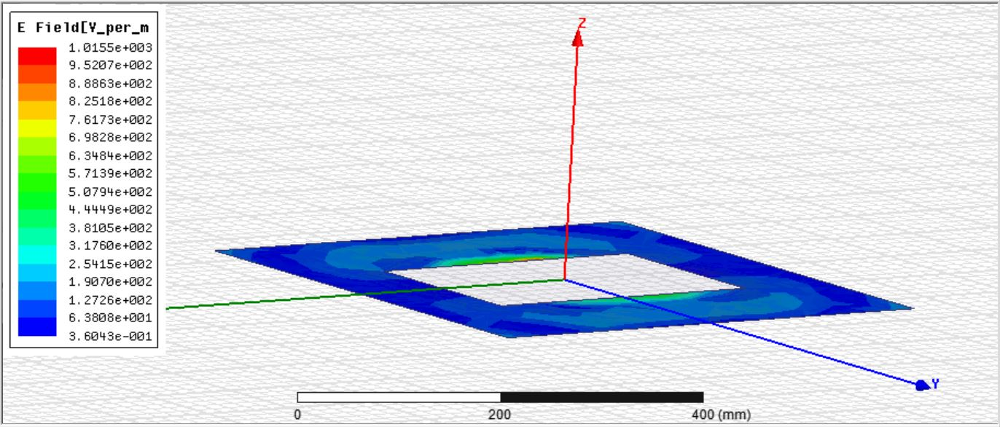

Figure . E plane 2 with decreased ground

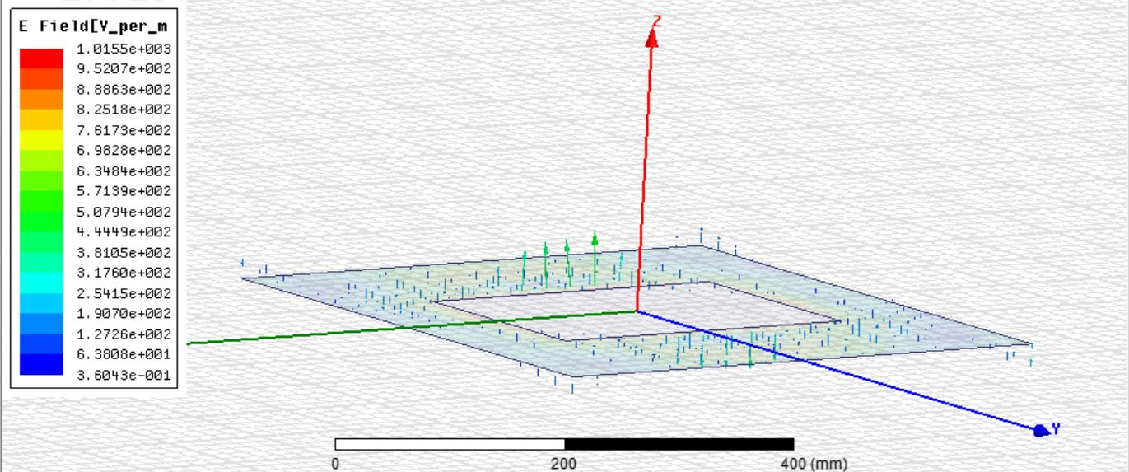

Figure . E plane 3 with decreased ground

H plane is like the following figure:

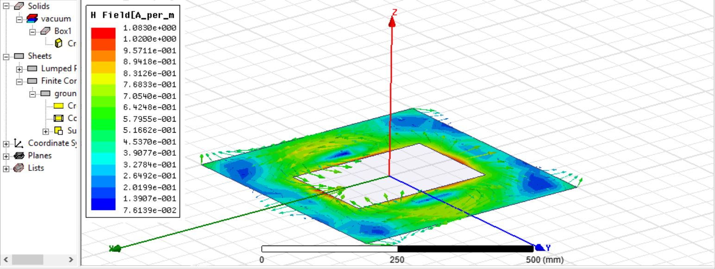

Figure . H plane 1 with decreased ground

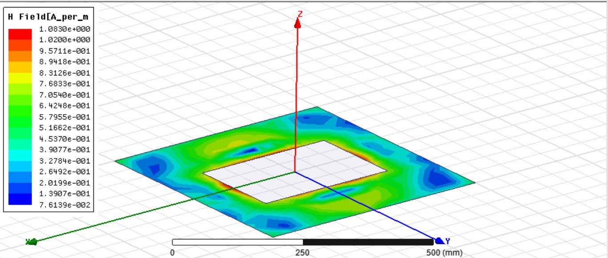

Figure . H plane 2 with decreased ground

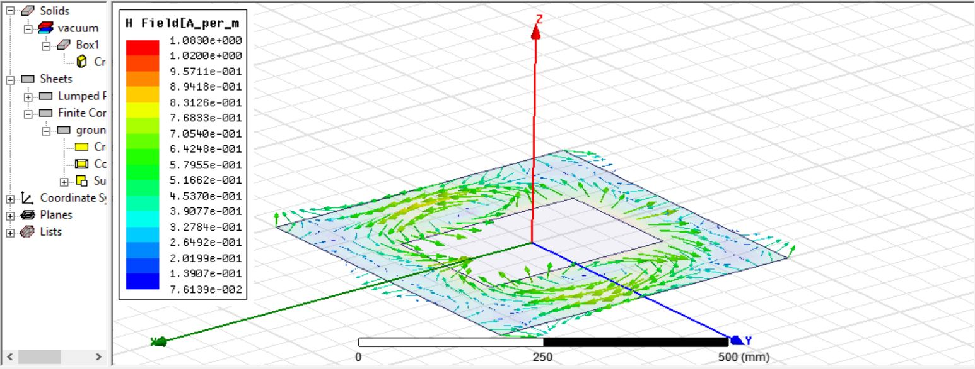

Figure . H plane 3 with decreased ground

For further analysis, we will analyze radiation pattern and directivity of the antenna.

3-D Radiation pattern:

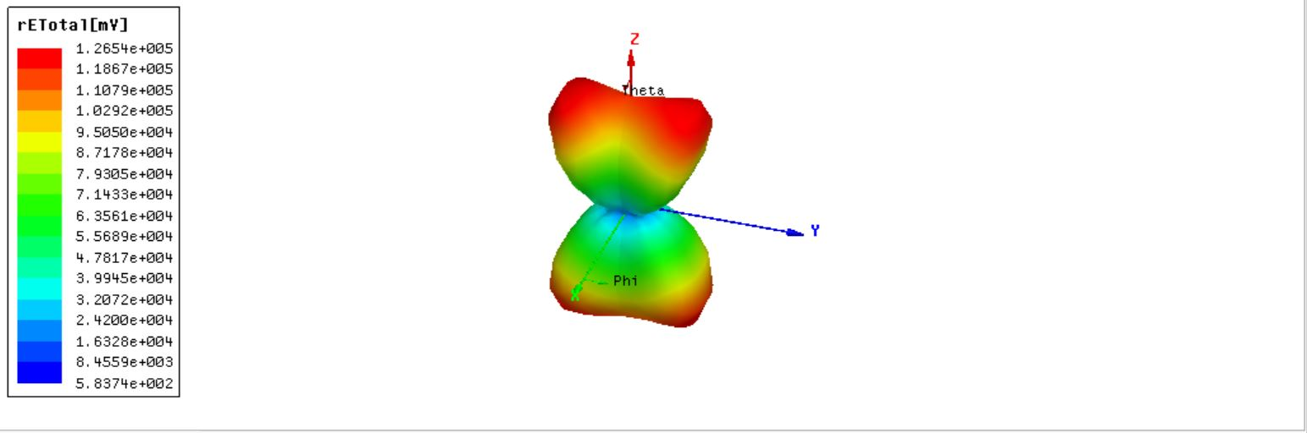

Figure . Radiation pattern in 3D view with decreased ground

Radiation pattern versus $θ$:

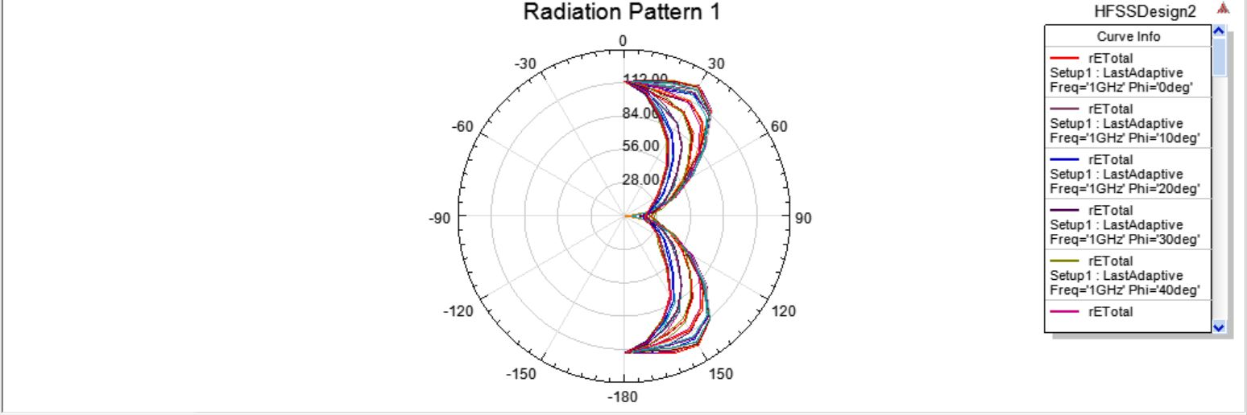

Figure . Radiation pattern versus $θ$ with decreased ground

Radiation pattern versus $ϕ$:

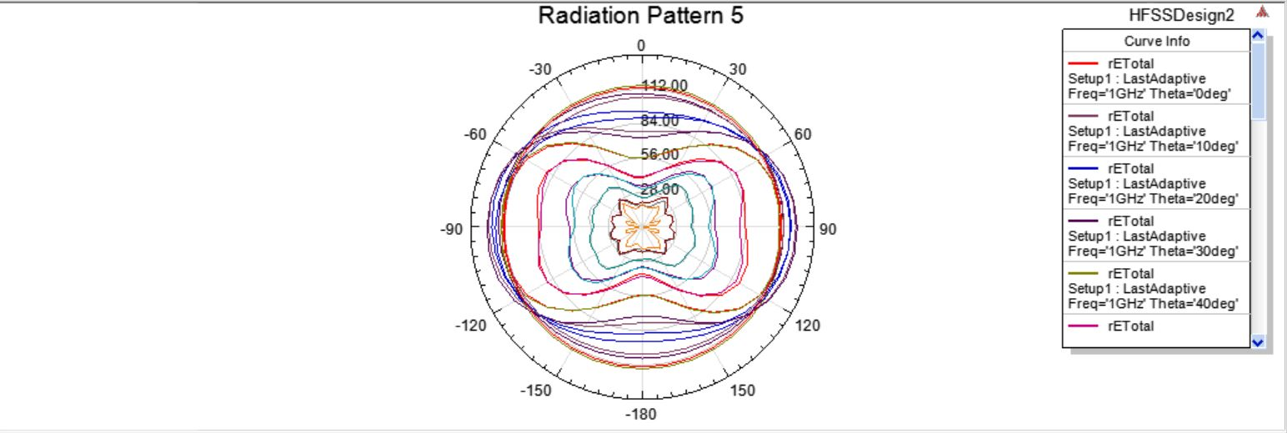

Figure . Radiation pattern versus ϕ with decreased ground

Directivity of the antenna:

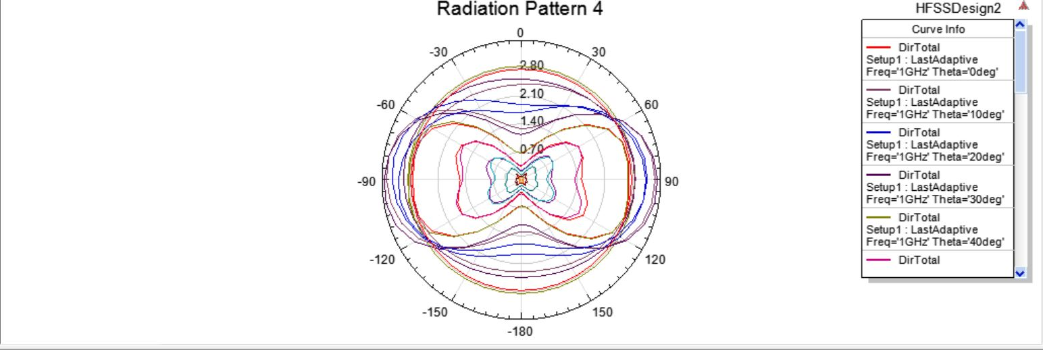

Figure . Directivity versus $ϕ$ with decreased ground

We can say that in this mode (decreased ground) the parameters of antenna has been decreased for example the radiation power and directivity. And the pattern of antenna has been cropped. Because the previous ground was more similar to the ideal ground.

## **Part c**

In this part, we should draw S11 versus frequency and determine the operation bandwidth. S11 for the ground size of 10λ × 10λ is as follows:

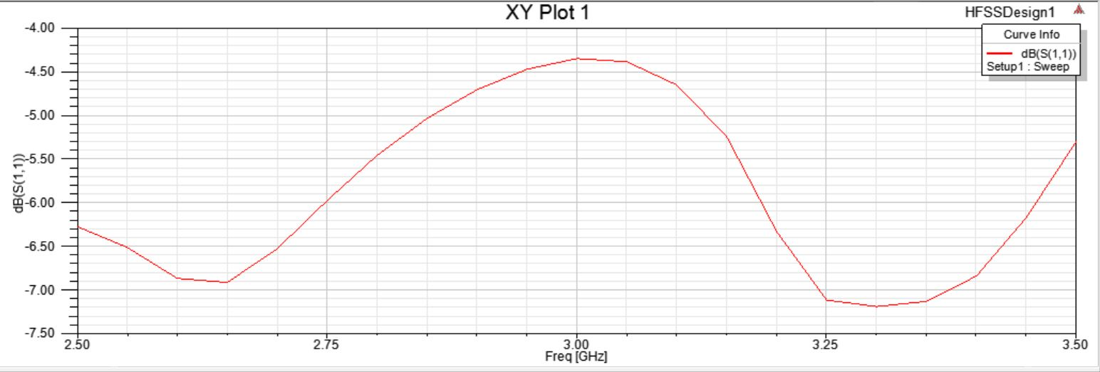

Figure . S11 for the ground size of $10λ*10λ$

S11 for the ground size of 5λ × 5λ is as follows:

s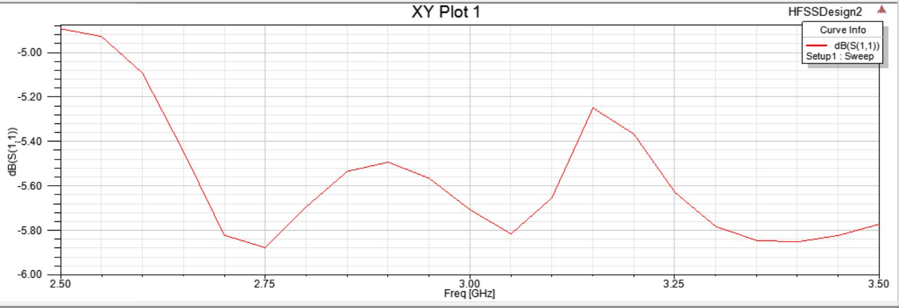

Figure . S11 for the ground size of $5λ*5λ$

As we can see S11 is not below -10dB neither in the first figure nor in the second one.

# **Question3**

In this question we Design a symmetrical two-wire planar spiral ( $φ_{0}$ = 0, π) to operate at the frequencies $f≥3 GHz$ with total feed terminal separation of ${10}^{-2}λ$. The wires are assumed to have radius of a = 0.0005λ, and made of copper. The structure is as below:

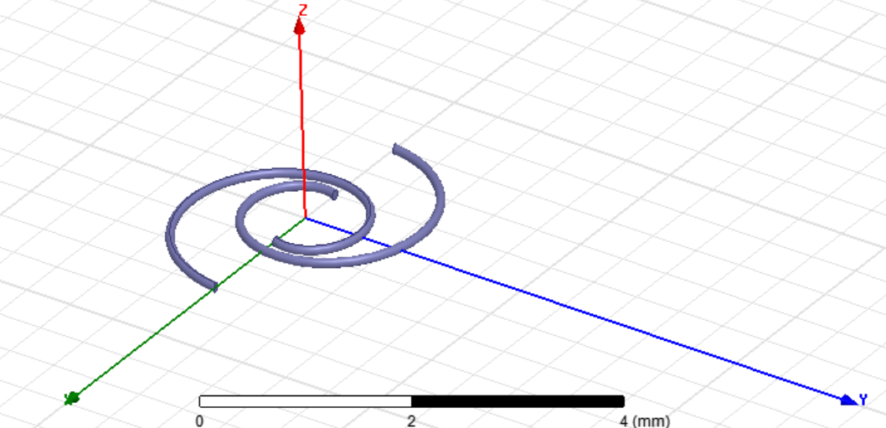

Figure . Spiral antenna

## **Part a**

In this part we plot $s_{11}$ versus frequency as below:

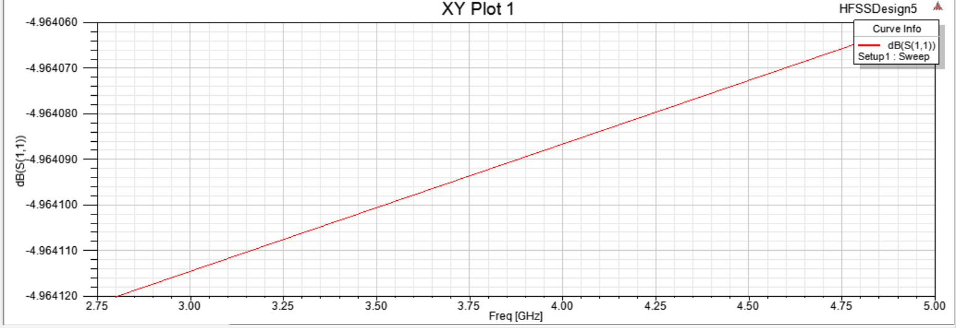

Figure . S11

We can say operation bandwidth is between 3GHz to 5GHz so the center frequency is 4 GHz.

## **Part b and c**

In this part we draw radiation pattern versus $θ$ and plot 3D model of directivity and gain for three frequencies selected at the beginning, center, and end of operation bandwidth (3GHz, 4GHz, 5Hz)

### **i. Beginning frequency (3GHz)**

The following figures are for frequency 3GHz:

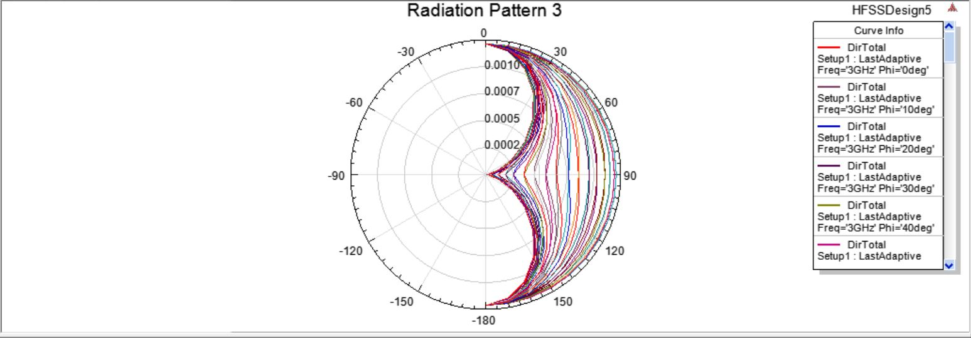

Figure . Radiation pattern versus $θ$ for 3GHz

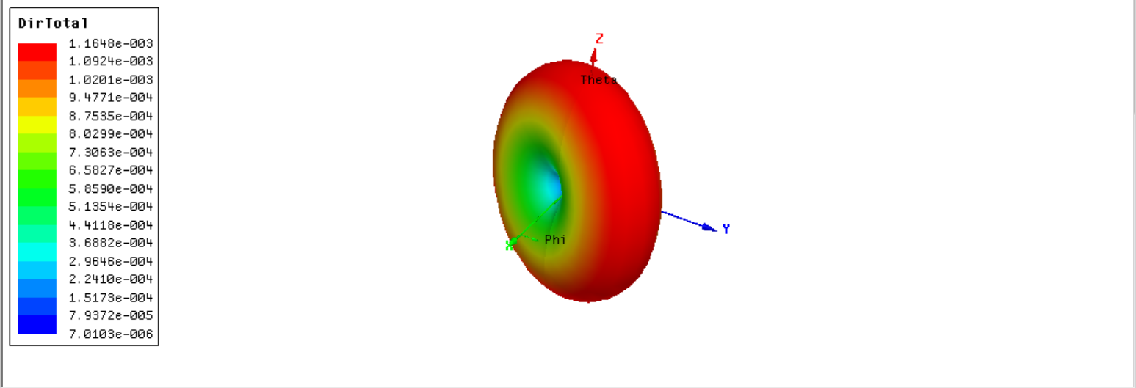

Figure . Directivity for 3GHz

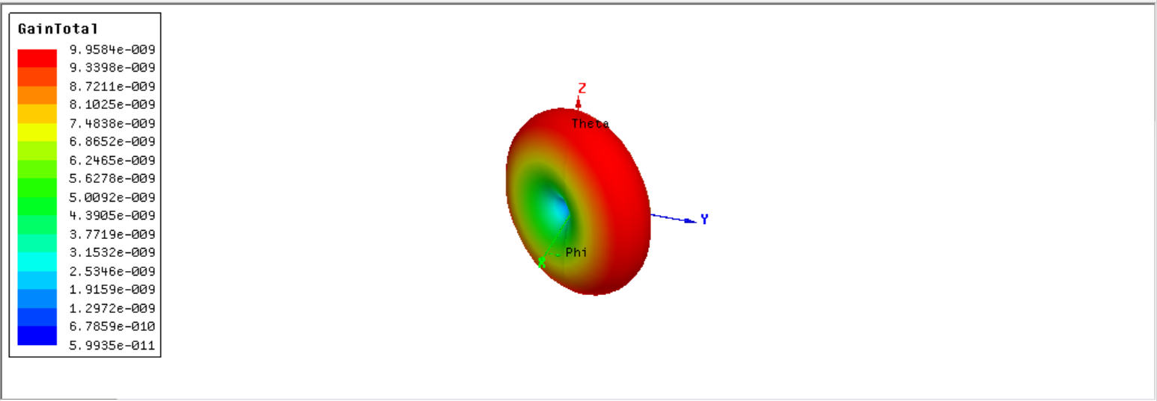

Figure . Gain for 3GHz

### **ii. Center frequency (4GHz)**

The following figures are for 4GHz:

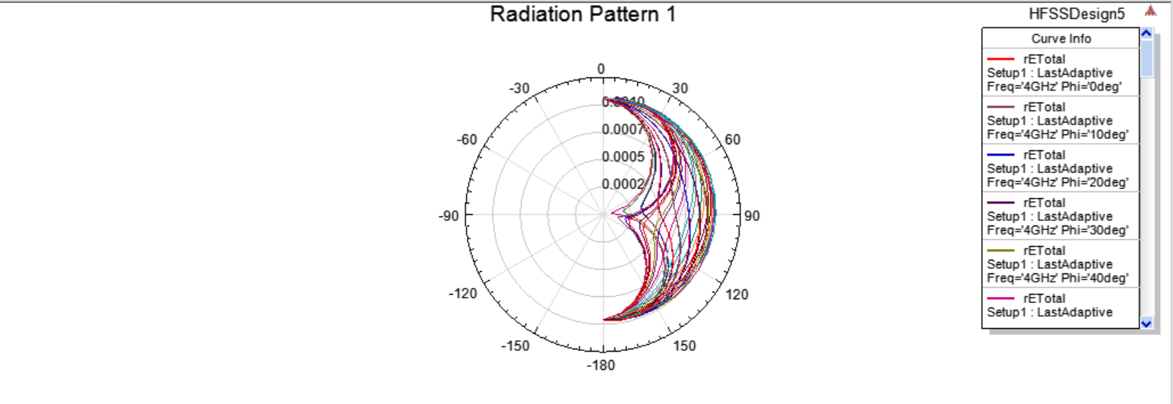

Figure . Radiation pattern versus $θ$ for 4GHz

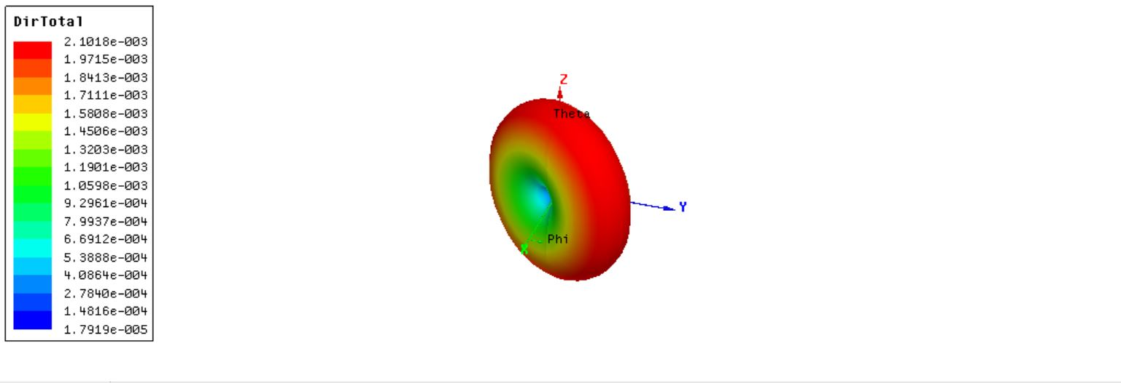

Figure . Directivity for 4GHz

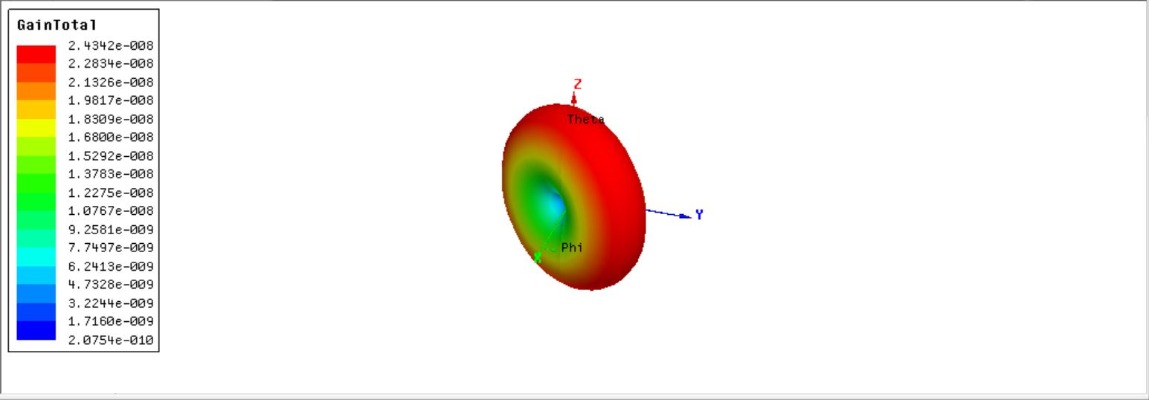

Figure . Gain for 4GHz

### **iii. End frequency (5GHz)**

The following figure are for 5GHz:

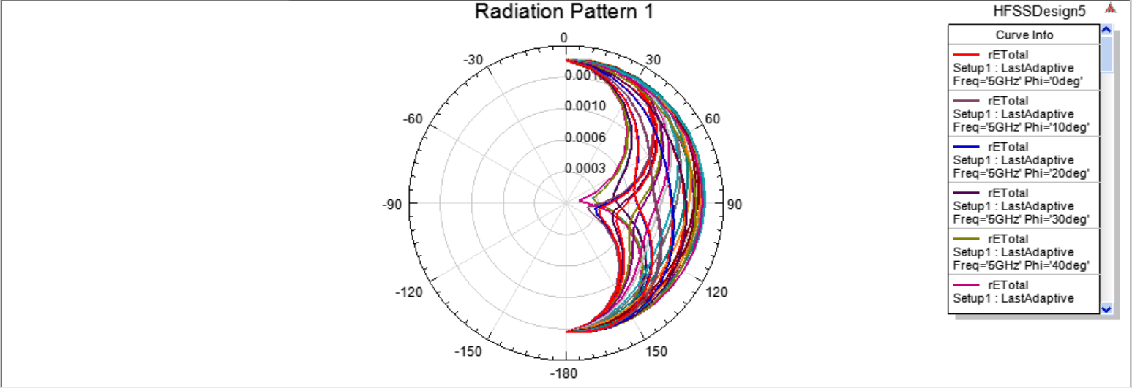

Figure . Radiation versus $θ$ for 5GHz

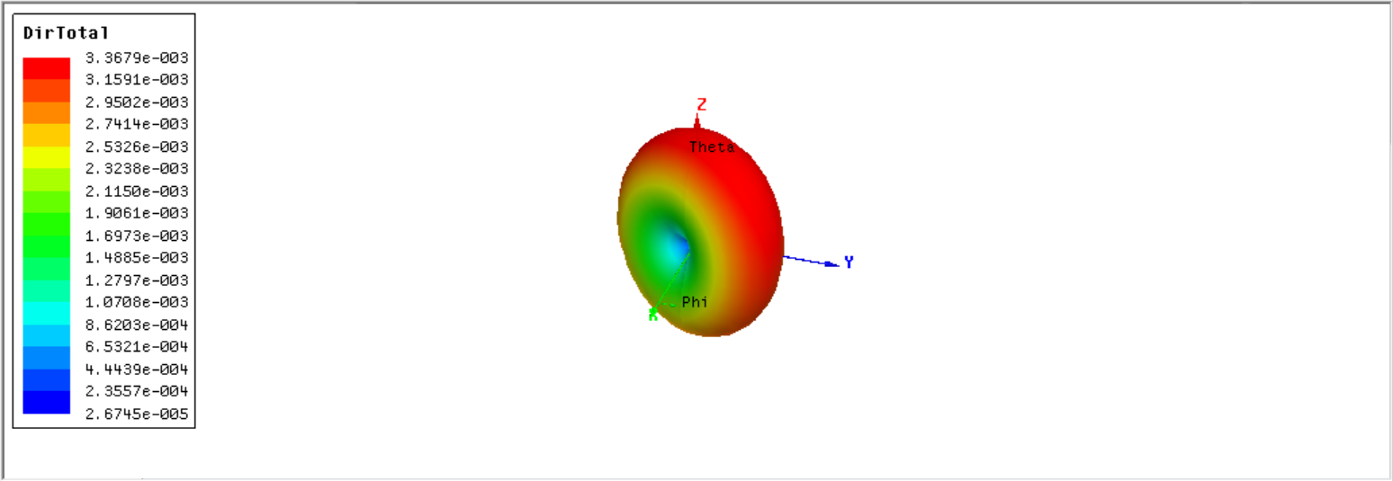

Figure . Directivity for 5GHz

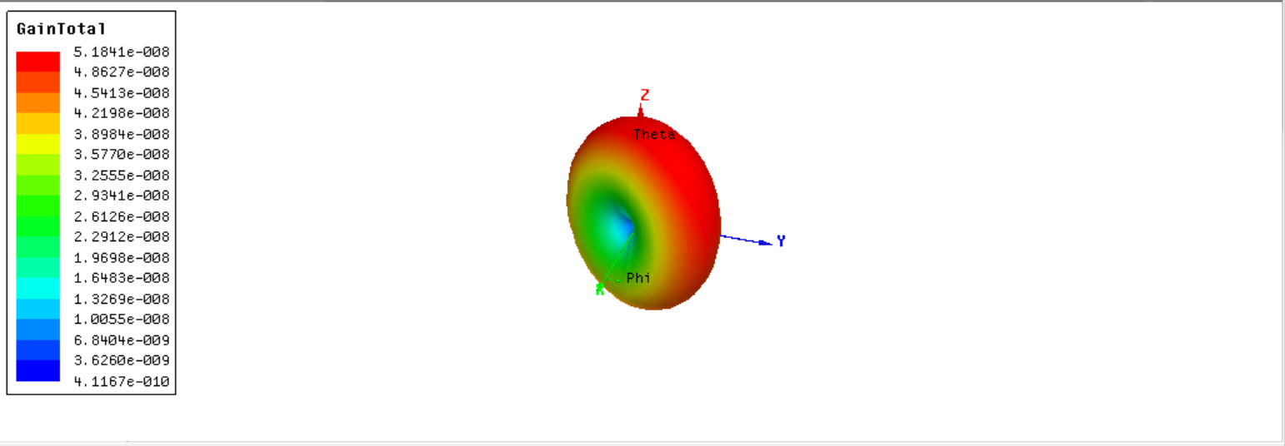

Figure . Gain for 5GHz

## **Part d**

In this part we plot current distribution over the wire:

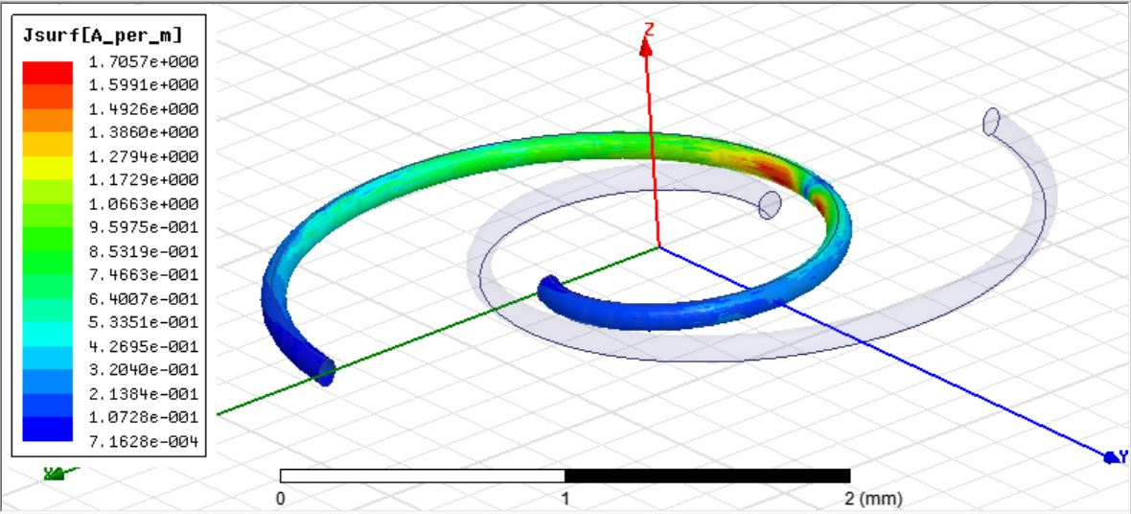

Figure . Magnitude of current

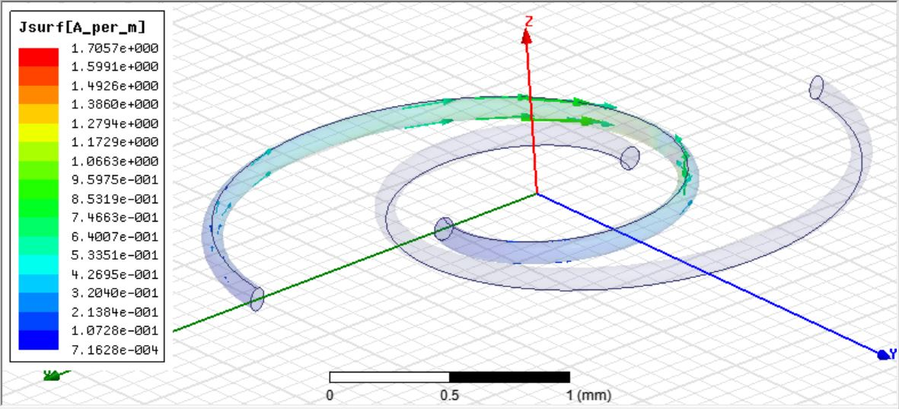

Figure . Current vector